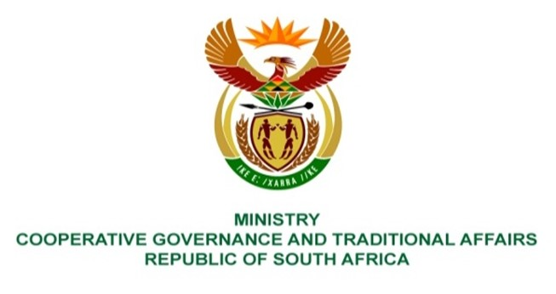

NATIONAL ASSEMBLY
QUESTIONS FOR WRITTEN REPLY

QUESTION NUMBER 2365
DATE OF PUBLICATION: 12 November 2021

Ms P Madokwe (EFF) to ask the Minister of Cooperative Governance and Traditional Affairs:
(a) What interventions has she and/or her department made to stop the water cuts in the (i) Matjhabeng Local Municipality and (ii) Nala Local Municipality, following the millions of rands owed by both municipalities to Sedibeng Water and (b) which officials have been held to account by her department for non-payment of the specified services?

REPLY:

- A joint national and provincial intervention was undertaken by the Deputy Minister of CoGTA, the Minister and Deputy Minister of Water and Sanitation and the MEC responsible for CoGTA in the Free State province which resulted in a series of engagements with the Sedibeng Water Board and its management team aimed at resolving the challenges impacting on water interruptions due to the debt owed by Nala and Matjhabeng Local Municipalities to Sedibeng Water Board. The national and provincial interventions undertaken resulted in payments made by both Nala and Matjhabeng local municipalities to the Sedibeng Water Board. Discussions are ongoing between Sedibeng Water and the Nala and Matjhabeng municipalities to finalise realistic and affordable payment plans to address the debt owed to Sedibeng Water.

- The Municipal Managers are appointed by the Municipal Councils, and it is therefore the responsibility of the Mayor and municipal council to hold officials to account for any practices relating to maladministration or misconduct.

