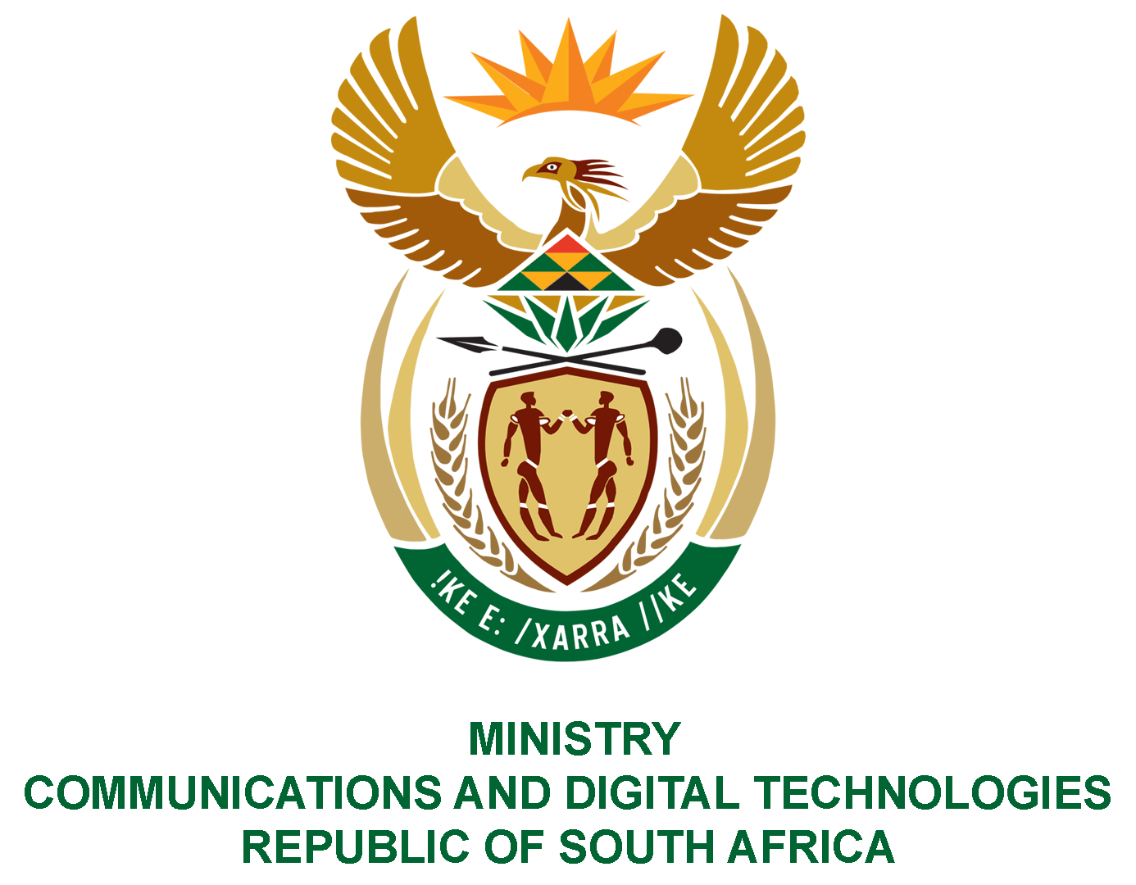

PARLIAMENT OF THE REPUBLIC OF SOUTH AFRICA
NATIONAL ASSEMBLY
WRITTEN REPLY

QUESTION NO: 2364
DATE OF PUBLICATION: 20 JUNE 2022
QUESTION PAPER NO: 24

Mr M S Malatsi (DA) to ask the Minister of Communications and Digital Technologies:
(1) (a) Who was appointed to design and develop the Digitech website that was launched by her department on 17 May 2022 and (b) what amount did the design and development of the website cost;
(2) whether her department is satisfied with the (a) functionality and (b) quality of the website; if not, what is the position in this regard; if so, what are the relevant details? NW2786E
REPLY:
I have been advised by the Department as follows:-

(1)(a) The State Information Technology Agency (SITA)
(1)(b) Nil

(2) (a) No
(2) (b) The website is being redesigned.

