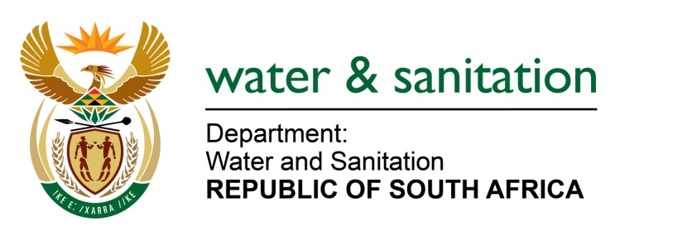

NATIONAL ASSEMBLY

FOR WRITTEN REPLY

QUESTION NO 2364

DATE OF PUBLICATION IN INTERNAL QUESTION PAPER: 28 OCTOBER 2016
(INTERNAL QUESTION PAPER NO. 33)
2364. Ms A Steyn (DA) to ask the Minister of Water and Sanitation:

With reference to her reply to question 1023 on 5 July 2016, (a) how many boreholes did her department (i) drill, (ii) repair and/or (iii) upgrade since 1 October 2015, (b) what is the exact GPS location of each of the specified boreholes, (c) what were the costs of (i) drilling per meter and/or (ii) refurbishment in each case and (d) was water found at each of the boreholes? NW2699E
---00O00---

REPLY:

(a) A total of 626 boreholes were drilled and a total of 519 Repaired/Upgraded/Refurbished (refer to table 1 below for details).

(b) Refer to Annexure A for the GPS location of each specified borehole.

(c)(i) The cost were from R 250 - R 1 455 depending on geological formation and other variables.

(c)(ii) The cost of refurbishment in each case was R 53, 6 million.

(d) No, water was found in all the boreholes excerpt for a few cases in KwaZulu-Natal (KZN).
Table 1. List of boreholes per province including costs:
Province | - Number of Boreholes |  | Costs (Rands) |  | (d)  Water Found
 | (i) Drilled | (ii)Repaired | (i) Per m drilled | (ii) Refurbished
Eastern Cape | 14 | 11 |  | R 20,4 M | Yes
Western Cape | - | - | - | - | -
Northern Cape | 23 | 47 | R750-R 1455 | R 21,7M | Yes
North West | 322 | 105 | R320 |  | Yes
Gauteng | - | - | - | - | -
Limpopo | - | - | - | - | -
Mpumalanga | 8 | 40 | R 900 | R 4,0M | Yes
KZN | 188 | 281 | R 250 –R350 | R 7,5M | Yes
Freestate | 71 | 35 | R 711 |  | Yes
TOTALS: | 626 | 513 |  | R 53,6 M
---00O00---

