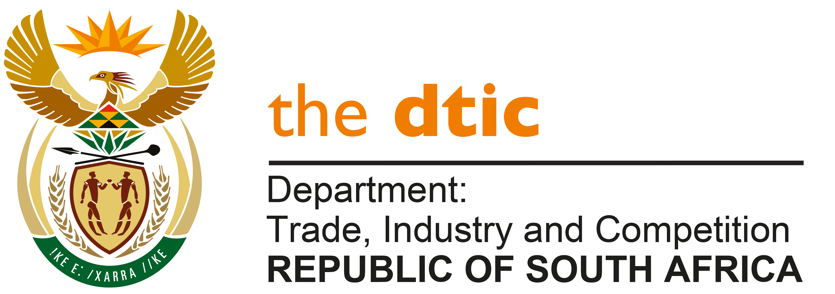

THE NATIONAL ASSEMBLY

QUESTION FOR WRITTEN REPLY

QUESTION NO: 2363

Mr M J Cuthbert (DA) to ask the Minister of Trade, Industry and Competition:

- What are the details of the fees earned by the board members of the National Lotteries Commission (NLC) for their involvement in licence bid evaluations?
- What number of meetings did each board member attend during the last bid evaluation which resulted in Ithuba being awarded the lottery operator licence?
- What is the (a) name of each board member who was involved and (b) total amount that each member earned during the previous licence adjudication?
- What have previous and/or current board members earned to date for attending meetings and/or other tasks related to the current adjudication for the new licence due to be awarded in 2023?
- What amount has the NLC budgeted to pay board members for their role in adjudicating the new licence? [NW2785E]

REPLY:

The previous Commissioner of the National Lotteries Commission (NLC), had furnished me with the following response to the questions:

- The Board members earned meeting fees for bid evaluations as detailed under Question 3.

- What number of meetings did each board member attend during the last bid evaluation which resulted in Ithuba being awarded the lottery operator licence?
BOARD MEMBER | 2013/14 | 2014/15
 | No of Meetings | No of Meetings
Prof NA Nevhutanda | - | 15
Adv. JC Weapond | 23 | 15
Prof G Reddy | 8 | 15
Ms M Mokoka | 14 | 15
Ms TS Kekana | - | 19
Ms NEP Loyilane | - | 14

- (a) Name of each board member who was involved and (b) total amount that each member earned during the previous licence adjudication.
- BOARD MEMBER | - 2013/14 | - 2014/15
 | R’000 | R’000
Prof NA Nevhutanda | - | 228
Adv JC Weapond | 167 | 114
Prof G Reddy | 10 | 88
Ms M Mokoka | 45 | 112
Ms TS Kekana | - | 76
Ms NEP Loyilane | - | 121

- Previous and/or current board members earned to date for attending meetings and/or other tasks related to the current adjudication for the new licence due to be awarded in 2023.
BOARD MEMBER | 2020/21 | 2021/22 | 2022/23
 | R’000 | R’000 | R’000
Prof NA Nevhutanda | 389 | - | -
Adv. WE Huma | 348 | - | -
Prof YN Gordhan | 361 | 114.11 | -
Dr MA Madzivhandila | 393 | 75.65 | -
Ms DLT Dondur | 436 | 108.92 | -

- The budget allocated for Board emoluments for member’s role in adjudicating amounts to R4, 594,015.00.
-END-

