**NATIONAL ASSEMBLY**

**QUESTION FOR** **WRITTEN REPLY**

**QUESTION NUMBER:** **2358 [NW2693E]**

**DATE OF PUBLICATION: 09 JUNE 2023**

**🟊****2358. Ms E R J Spies (DA) to ask the Minister of Finance:**

(1) Whether he will furnish Ms E R J Spies with a list of municipalities that are currently in arrears with the payment of their mandatory pension and medical contributions for staff and councillors; if not, what is the position in this regard; if so, what are the relevant details;

(2) (a) for how long has each specified municipality not been paying the arrears, (b) what is the total amount of the specified arrears, (c) what corrective action has the National Treasury taken against the defaulting municipalities and (d) what steps have been taken to compensate councillors and municipal staff who are affected by the specified nonpayment;

(3) whether any criminal charges have been laid against the accounting officers who are mandated by the Local Government: Municipal Finance Management Act, Act 56 of 2003, to take all reasonable steps to ensure that they, among other obligations, comply with the pension and medical aid commitments of councillors and municipal staff; if not, why not; if so, what are the relevant details? NW2693E

**REPLY**

1. National Treasury collects outstanding creditor’s information via the Local Government Database and Reporting System (LGDRS) hosted by National Treasury on monthly basis. However, although the list of outstanding creditors includes pension fund contributions, it does not provide a breakdown for outstanding medical aid contributions but this category is lumped under other payables. The National Treasury is putting measures to facilitate the collection of such information for further purposes. Another challenge is that some municipalities might choose not to disclose this information in their submissions to the National Treasury’s database which makes it challenging to get an accurate picture of municipalities owing the Pension Funds.

At this stage, the only four (4) municipalities in the Free State and five (5) in the Northern Cape have disclosed the information on arrears of monthly statutory contributions to the Pension Fund. However, municipalities in Limpopo and Mpumalanga disclosed no arrears since they are up to date with their respective monthly contributions to the Pension and Medical Aid Funds. The information is listed in **Annexure A**.

(2)(a)(c) The National Treasury has communicated the criteria for the release of the Equitable Share in its annual Budget Circulars. Included in the criteria is the requirement to table a funded budget in terms of Section 18 of the MFMA as well as making adequate provision to repay all creditors in terms of Section 65(2)(f) of the MFMA.

Every time we received correspondence from the respective pension funds administrator on outstanding payments / accounts, the National Treasury will send a letter to the respective municipality requesting reasons as to why they have defaulted.

(2)(b) The total amount reported for pension fund contributions are consolidated Retirement Fund R23.7 million and Municipal Workers Retirement Fund R6.3 million. More details attached as **Annexure A.**

(2)(d) At this stage, none of the above listed municipalities compensated any municipal officials or councillors affected by the no-payment of monthly contributions to the Pension Funds and/ or Medical Aid Funds. The responsibility to ensure this is avoided at all costs is with the respective Municipal Councils.

However, at Renosterberg Municipality, the municipal employees instituted a lawsuit against the municipality by an affected municipal official but there was no follow through, and the lawsuit was dropped.

(3) As indicated before, at Renosterberg Municipality, criminal charges were laid against the former administrative and political leadership (Municipal Manager, the Chief Financial Officer and the Mayor). At this stage, no arrest has been made and the criminal case is still under investigation by the law enforcement agencies as of May / June. The municipality had not received further communication from the law enforcement officers other than the charge sheet.

As for the remainder of the above listed municipalities, no criminal cases were reported to the police and reason cited by the Provincial Treasury was the instability at senior management in the respective municipalities that hampered the implementation of consequence management.

**Annexure A**

**Kai Garib Local Municipality:**

**(2)(a)** **For how long has each specified municipality not been paying the arrears?**

The municipality reported to have defaulted on third party payments since February 2022.

**(2)(b)** The total amount reported for pension fund contributions.

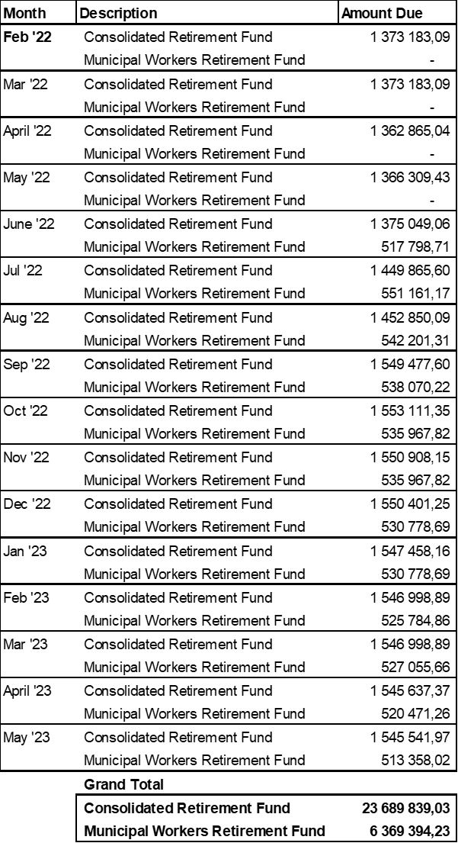

**Renosterberg Local Municipality:**

**2 (a)** **For how long has each specified municipality not been paying the arrears?**

The municipality reported to have defaulted on third party payments since May 2017.

**2 (b) What is the total amount of the specified arrears?**

The total amount reported for pension fund contributions and medical aid amounts to R19 million.



**Ubuntu Local Municipality:**

**2 (a)** **For how long has each specified municipality not been paying the arrears?**

The municipality reported to have defaulted on third party payments since March 2023.

**2 (b) What is the total amount of the specified arrears?**

The total amount reported for third parties amounts to R3.4 million.



**Thembelihle Local Municipality:**

**2 (a)** **For how long has each specified municipality not been paying the arrears?**

Defaulted from December 2021.

**2 (b) What is the total amount of the specified arrears?**

The total amount reported for pension fund contributions (cape joint retirement fund and amounting to R5.1 million.



**Kheis Local Municipality:**

**2 (a)** **For how long has each specified municipality not been paying the arrears?**

The municipality reported to have defaulted on third party payments since July 2021.

**2 (b) What is the total amount of the specified arrears?**

The total amount reported for pension fund contributions and medical aid amounts to R19.9 million.

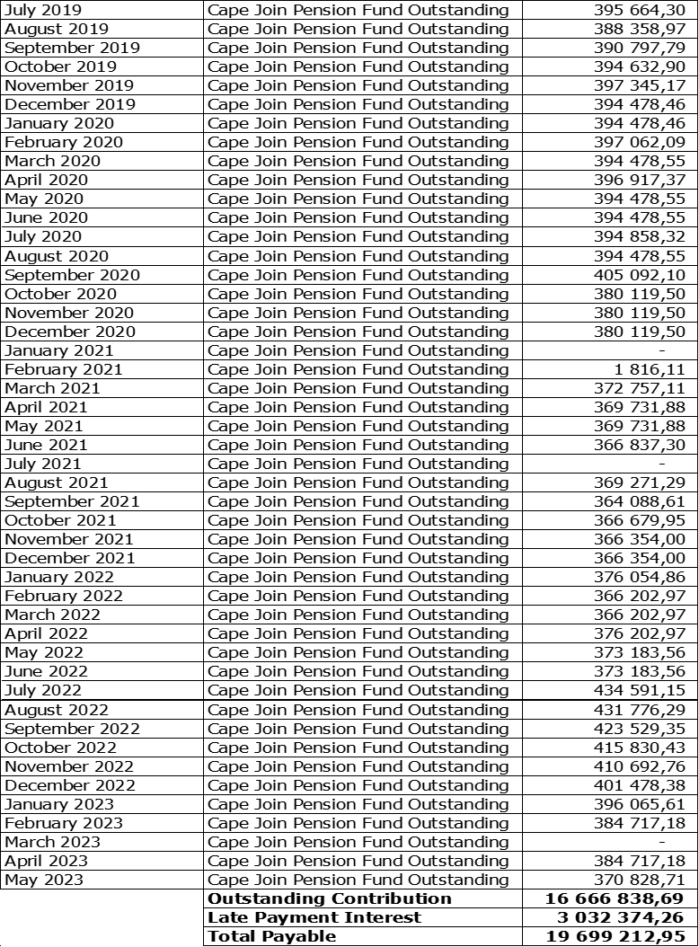

**Magareng Local Municipality:**

**2 (a)** **For how long has each specified municipality not been paying the arrears?**

The municipality reported to have defaulted on third party payments since March 2021.

**2 (b) What is the total amount of the specified arrears?**

The total amount reported for third parties amounts to R4.3 million.

