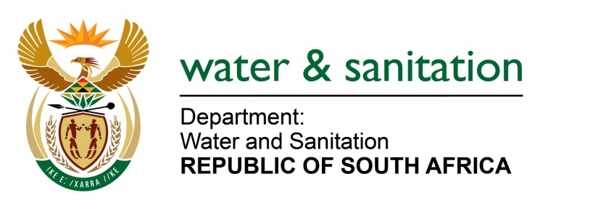
Annexure A
- Gauteng:
No | Municipality | System Input Volume  (million m³/annum) | Population (No)
1 | City of Johannesburg | 578.392 | 4 885 083
2 | Ekurhuleni | 363. 964 | 3 247 008
3 | City of Tshwane | 351.883 | 3 102 908
4 | Emfuleni | 98.141 | 725 157
5 | Mogale City | 30.915 | 366 943
6 | Rand West City | 15.677 | 250 730
7 | Midvaal | 13.843 | 106 681
8 | Merafong City | 13.477 | 183 585
9 | Lesedi | 6.809 | 110 186

- Kwa-Zulu Natal:
No | Municipality | System Input Volume  (million m³/annum) | Population (No)
1 | eThekwini | 325.289 | 3 481 726
2 | Msunduzi | 71.399 | 653 248
3 | Uthukela DM | 51.716 | 490 632
4 | City of uMhlathuze | 46.642 | 363 899
5 | Ugu District | 41.821 | 483 816
6 | Zululand District | 34.333 | 514 803
7 | Newcastle | 32.667 | 379 345
8 | Umgungundlovu District | 19.742 | 313 257
9 | Ilembe District | 17.474 | 401 004
10 | Umkhanyakude District | 15.478 | 312 030

- Western Cape:
No | Municipality | System Input Volume  (million m³/annum) | Population (No)
1 | City of Cape Town | 329.004 | 3 903 674
2 | Drakenstein | 18.615 | 275 920
3 | Breede Valley | 15.297 | 167 818
4 | Saldanha Bay | 13.869 | 107 875
5 | Stellenbosch | 13.485 | 165 019
6 | George | 12.391 | 205 273
7 | Langeberg | 7.763 | 102 624
8 | Oudtshoorn | 7.613 | 94 664
9 | Mossel Bay | 7.533 | 89 931
10 | Overstrand | 7.338 | 92 220

- Eastern Cape:
No | Municipality | System Input Volume  (million m³/annum) | Population (No)
1 | Nelson Mandela Bay | 115.447 | 1 240 387
2 | Buffalo City | 66.792 | 747 070
3 | O.R.Tambo District | 35.896 | 433 984
4 | Chris Hani District | 29.73 | 574 111
5 | Amatole District | 27.449 | 506 772
6 | Sarah Baartman District | 27.135 | 438 181
7 | Alfred Nzo District | 17.964 | 285 156
8 | Joe Gqabi District | 11.708 | 252 257
9 | Kouga | 6.836 | 104 801
10 | Dr Beyers Naude | 5.379 | 76 439

- Northern Cape:
No | Municipality | System Input Volume  (million m³/annum) | Population (No)
1 | Sol Plaatjie | 33.418 | 248 168
2 | Dawid Kruiper | 13.19 | 102 535
3 | Ga-Segonyana | 4.687 | 73 357
4 | Joe Morolong | 4.523 | 57 107
5 | Phokwane | 2.284 | 54 099
6 | Gamagara | 3.873 | 52 439
7 | Kai Garib | 3.798 | 60 170
8 | Emthanjeni | 3.438 | 45 222
9 | Siyathemba | 2.571 | 22 413
10 | Nama Khoi | 2.411 | 45 659

- Limpopo:
No | Municipality | System Input Volume  (million m³/annum) | Population (No)
1 | Mopani District | 109.841 | 766 242
2 | Capricorn District | 64.442 | 1 144 203
3 | Vhembe District | 46.897 | 963 853
4 | Polokwane | 42.527 | 630 356
5 | Greater Sekhukhune District | 29.938 | 716 431
6 | Mogalakwena | 10.686 | 272 164
7 | Lephalale | 6.101 | 122 280
8 | Thabazimbi | 5.13 | 73 699
9 | Modimolle/Mookgophong | 4.253 | 97 004
10 | Bela Bela | 3.948 | 70 091

- Free State:
No | Municipality | System Input Volume  (million m³/annum) | Population (No)
1 | Mangaung | 72.306 | 739 382
2 | Matjhabeng | 36.627 | 417 209
3 | Maluti a Phofung | 20.46 | 310 971
4 | Metsimaholo | 14.642 | 161 036
5 | Moqhaka | 10.639 | 152 735
6 | Dihlabeng | 9.158 | 133 915
7 | Ngwathe | 8.041 | 114 824
8 | Setsoto | 7.369 | 114 134
9 | Nala | 3.53 | 77 075
10 | Masilonyana | 3.333 | 63 259

- North West:
No | Municipality | System Input Volume  (million m³/annum) | Population (No)
1 | Rustenburg | 52.472 | 578 968
2 | Ngaka Modiri Molema District | 42.636 | 672 303
3 | City of Matlosana | 33.337 | 407 562
4 | Madibeng | 23.94 | 434 354
5 | Dr Ruth Mompati District | 15.843 | 347 558
6 | J B Marks | 15.048 | 169 237
7 | Moses Kotane | 11.148 | 185 534
8 | Moretele | 5.125 | 109 124
9 | Maquassi Hills | 3.517 | 78 753
10 | Kgetlengrivier | 3.43 | 56 602

- Mpumalanga:
No | Municipality | System Input Volume  (million m³/annum) | Population (No)
1 | Mbombela | 52.684 | 502 466
2 | Emalahleni | 48.017 | 402 509
3 | Govan Mbeki | 32.775 | 334 667
4 | Dr J S Moroka | 23.098 | 216 238
5 | Steve Tshwete | 19.027 | 259 710
6 | Thembisile | 17.594 | 309 310
7 | Bushbuckridge | 17.172 | 391 782
8 | Nkomazi | 12.981 | 298 997
9 | Msukaligwa | 7.718 | 149 498
10 | Mkhondo | 8.488 | 155 458

