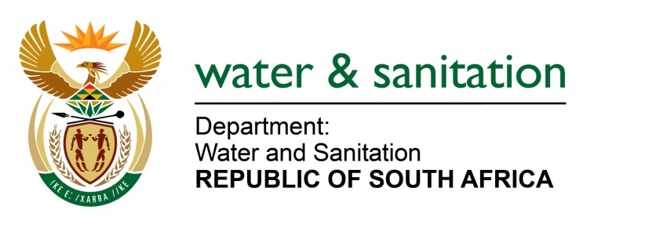

NATIONAL ASSEMBLY

FOR WRITTEN REPLY

QUESTION NO 2354

DATE OF PUBLICATION IN INTERNAL QUESTION PAPER: 14 AUGUST 2017
(INTERNAL QUESTION PAPER NO. 26)
2354. Mr T Z Hadebe (DA) to ask the Minister of Water and Sanitation:
(a) What amount was spent on emergency works at waste water treatment plants in each province in the (i) 2014-15, (ii) 2015-16 and (iii) 2016-17 financial years and (b) what are the details of the (i) locations, (ii) name of each municipality, (iii) nature of the intervention and (iv) cost of the intervention in each case? NW2599E
---00O00---
REPLY:
My Department did not implement any emergency Waste Water Treatment Plants (WWTP) projects in the 2014/15 and 2015/16 financial years. The amount spent on emergency works at waste water treatment plants in each province in the 2016-17 financial years is detailed in the table below:
PROVINCE | LOCATION | MUNICIPALITY | PROJECT NAME | NATURE OF INTERVENTION | PROJECT COST
Free Sate | Oranjeville | Metsimaholo | Refurbishment of Oranjeville Waste Water Treatment Works. | Refurbishment of WWTW and Pump Stations (Mechanical and Electrical) | R8 012 848.39
Free Sate | Deneysville | Metsimaholo | Refurbishment of Deneysville Waste Water Treatment Works. | De-sludging of WWTW ponds | R2 468 343.42
Free Sate | Vrede | Phumelela | Refurbishment of Vrede Waste Water Treatment Works. | Refurbishment of WWTW and Pump Stations (Mechanical and Electrical) | R42 457 532.10
Free Sate | Harrismith | Maluti-A-Phofung | Refurbishment of Wilge Waste Water Treatment Works. | Refurbishment of WWTW (Mechanical and Electrical) | R11 853 659.90
Free Sate | Reitz | Nketoana | Refurbishment of Reitz Waste Water Treatment Works. | De-sludging of WWTW ponds and the refurbishment of Mechanical and Electrical components. | R24 409 008.78
Free Sate | Viljoenskroon | Moqhaka | Refurbishment of Viljoenskroon Waste Water Treatment Works. | Refurbishment of WWTW (Mechanical and Electrical) | R15 058 146.26
Free Sate | Bothaville | Nala | Refurbishment of Bothaville Waste Water Treatment Works. | Refurbishment of WWTW and Pump Stations (Mechanical and Electrical) | R17 163 326.86
Free Sate | Frankfort | Mafube | Refurbishment of Frankfort Waste Water Treatment Works. | De-sludging of WWTW ponds and the refurbishment of Mechanical and Electrical components. | R8 816 442.23
Free Sate | Villiers | Mafube | Refurbishment of Villiers Waste Water Treatment Works. | De-sludging of WWTW ponds and the refurbishment of Mechanical and Electrical components. | R8 217 708.53
Free Sate | Qalabotjha | Mafube | Refurbishment of Qalabotjha Waste Water Treatment Works. | De-sludging of WWTW ponds and the refurbishment of Mechanical and Electrical components. | R16 634 295.75
Free Sate | Namahadi | Mafube | Refurbishment of NamahadiWaste Water Treatment Works. | De-sludging of WWTW ponds and the refurbishment of Mechanical and Electrical components. | R27 685 929.09
Free Sate | Parys | Ngwathe | Refurbishment of ParysWaste Water Treatment Works. | Refurbishment of WWTW (Mechanical and Electrical) | R2 450 308.16
Northern Cape | Warrenton | Magareng | Refurb of Warrenton WWTW | Refurbishment | R 10 77 712
Northern Cape | Barkly West | Dikgatlong | Refurb of Barkly West WWTW | Refurbishment | R 14 592 052
Northern Cape | Douglas | Siyancuma | Refurb of Douglas WWTW | Refurbishment | R 23 367 715
Northern Cape | Olifantshoek | Gamagara | Refurb of Olifantshoek | Refurbishment | R 12 925 769
Northern Cape | Dibeng | Gamagara | Refurb of Dibeng WWTW | Refurbishment | R 10 108 813
Mpumalanga | Ermelo | Ermelo  (Mpumalanga) | Refurb of Ermelo WWTW | Upgrade | R 44 275 029.44
Gauteng | Leekuil | Leekuil(Vaal) | Refurb of Leekuil WWTW | Refurbishment | R 36 417 498.79
Mpumalanga | Standerton | Standerton | Refurb of Standerton WWTW | Refurbishment | R 14 502 308.22
Gauteng | Vaal Marina | Vaal Marina | Refurb of Vaal Marina WWTW | Refurbishment | R 7 951 441.09

---00O00---

