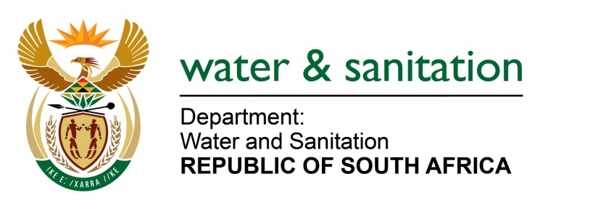

NATIONAL ASSEMBLY

FOR WRITTEN REPLY

QUESTION NO 2351

DATE OF PUBLICATION IN INTERNAL QUESTION PAPER: 14 AUGUST 2017
(INTERNAL QUESTION PAPER NO. 26)
2351. Mr L J Basson (DA) to ask the Minister of Water and Sanitation:
(a) What are the qualifications requirements for the position of General Manager of the Project Management Unit at Magalies Water, (b) who is the current incumbent, (c) is the person serving in a permanent capacity and (d) what are the details of the specified person’s qualifications? NW2596E
---00O00---
REPLY:

- Relevant Degree or BTech in Civil Engineering, Master Degree advantageous (The job advert of the position is attached).
- The current incumbent is Ms Tsakane Radebe.

- The position is a 5-year contract and the successful candidate assumed her duties effective from the 01 May 2016.

- The details of the specified person’s qualifications are as follows:
- Matric
- National Diploma: Mechanical Engineering
- Bachelor of Technology: Mechanical Engineering
- Project Management Professional
- Certified Associate in Project Management

---00O00---

