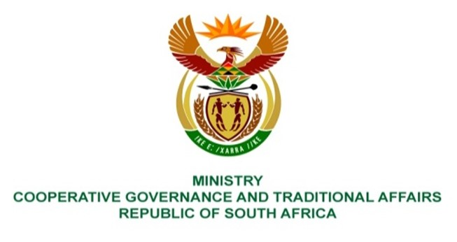

NATIONAL ASSEMBLY
QUESTION FOR WRITTEN REPLY

QUESTION NUMBER 235
DATE OF PUBLICATION: 10 FEBRUARY 2022

QUESTION:

235. Mr K Ceza (EFF) to ask the Minister of Cooperative Governance and Traditional Affairs:
What intervention has she made to resolve the perennial financial problems at Amahlathi Local Municipality in the Eastern Cape, which has consistently failed to pay its workers because it has financially collapsed? NW242E

REPLY:
The municipality was previously placed under intervention in terms of sec 139(1)(b) and (5) of the Constitution between March 2019 to November 2019. An administrator was appointed in line with subsection 5(c) of the Constitution from the beginning of March 2019.
Forensic investigations were instituted by the Eastern Cape Provincial CoGTA in accordance with section 106 of the Municipal Systems Act to probe allegations of procurement processes and irregularities.
In January 2020, the MEC for Cooperative Governance and Traditional Affairs in the Eastern Cape wrote a letter to the National Department requesting financial bailout on 16 financially distressed municipalities including Amahlathi Local Municipality. A joint technical team comprising of CoGTA. Provincial CoGTA, National and Provincial Treasury and SALGA was convened to develop a diagnostic report on the challenges in identified municipalities ranging from governance, institutional capacity, service delivery and financial management, wherafter recommendations were made to this effect.
The financial paralyses in Amahlathi Municipality comprise of various factors, including structural and systematic issues, institutional stabilization, administrative and governance matters. The wage bill of the municipality is significantly higher than the norm of 40% and unprocedural processes on the standardization of salaries has increased the wage bill.
Amahlathi Municipality is amongst the 64 municipalities identified in the recent State of Local Government Report as being dysfunctional. The Department is working jointly with the National Treasury, SALGA and their provincial counterparts, and municipalities to finalize the Municipal Support and Intervention Plans.
The Department has promulgated the Municipal Staff Regulations in September 2021, setting out amongst others uniform norms and standards for municipal staff systems and procedures, including organisation design principles, financial ratios, organisation design norms and metrics. The implementation of these Regulations will provide needed stability and curtail the bloating of municipalities.
In addition, the implementation of the Regulations comes with the prototype staff establishments. The Department is on the verge of rolling out the prototype staff establishments in selected municipalities, including Amahlathi Municipality, which is aimed at guiding municipalities to organise their administration in such a manner that they are fit for purpose and responsive to the needs of communities.

