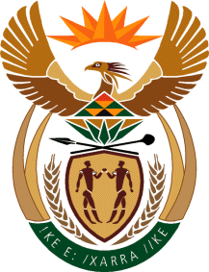

MINISTRY OF TOURISM
REPUBLIC OF SOUTH AFRICA

Private Bag X424, Pretoria, 0001, South Africa. Tel. (+27 12) 444 6780, Fax (+27 12) 444 7027
Private Bag X9154, Cape Town, 8000, South Africa. Tel. (+27 21) 469 5800, Fax: (+27 21) 465 3216

NATIONAL ASSEMBLY:

QUESTION FOR WRITTEN REPLY:
Question Number: 235
Date of Publication: 12 July 2019
NA IQP Number: 4
Date of reply:

Mr M S F de Freitas (DA) to ask the Minister of Tourism:

With regard to performance agreements for her and the Deputy Minister, what are the (a) key performance indicators, (b) measuring and monitoring mechanisms and (c) timelines, milestones and deadlines in this regard? NW1194E

REPLY:
Approval of the MTSF by Cabinet provides a basis for the Minister and Deputy Minister’s performance agreements. As such, the Minister and the Deputy Minister’s performance agreements for the current term will be finalised in line with the Medium Term Strategic Framework (MTSF), which is due to be approved by Cabinet in August 2019.

(a) Key Performance Indicators
Not applicable

(b) Measuring and Monitoring mechanisms
Not applicable

- Timelines, milestones and deadlines
Not applicable

