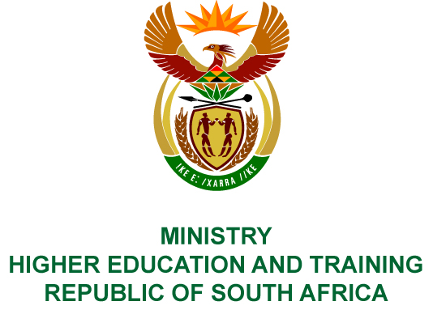
Private Bag X893, Pretoria, 0001, Tel (012) 312 5555, Fax (012) 323 5618
Private Bag X9192, Cape Town, 8000, Tel (021) 469 5150, Fax: (021) 465 7956
Memorandum from the Parliamentary Office
NATIONAL ASSEMBLY
FOR WRITTEN REPLY
QUESTION 235
DATE OF PUBLICATION OF INTERNAL QUESTION PAPER: 16/02/2018

(INTERNAL QUESTION PAPER NO 2 OF 2018)
Mr P Moteka (EFF) to ask the Minister of Higher Education and Training:
What was the total remuneration paid to each board member of the National Institute for the Humanities and Social Sciences in the (a) 2014-15, (b) 2015-2016 and (c) 2016-17 financial years?
NW256E

REPLY:
The National Institute for Humanities and Social Sciences (NIHSS) has provided the following responses to the questions posed.
The Board members were remunerated as follows for the 2014/15, (b) 2015/2016 and (c) 2016/17 financial years:
 |  | (a) | (b) | (c)
# | Name of Board Member | 2014/15 | 2015/16 | 2016/17
 | Prof Aristides Sitas (Chairperson) | R20 000 | R13 160 | R40 355
 | Prof Ahmed Bawa | R10 000 | - | R7 575
 | Dr Vukile Khumalo | R12 665 | R4 743 | -
 | Dr Pamela Maseko (resigned July 2017) | R10 000 | R6 925 | R27 630
 | Dr Bernard Nthambeleni | R7 500 | R10 483 | R28 660
 | Prof Sam Moyo | R5 000 | R2 550 | -
 | Prof Fiona Tregenna | R10 000 | R6 925 | R23 300
 | Mr Alex Mashilo | R5 000 | R5 000 | R10 100
 | Ms Luli Callinicos | R12 500 | R7 925 | R14 500
 | Mr Ivor Baatjes | - | R2 500 | R19 550
 | Prof Rosemary Moeketsi | R14 500 | R6 050 | R28 495
 | Mr John Pampallis | - | - | R48 580
 | Mr Stephen Smith | - | - | R27 370
 | Mrs Nokuthula Selamolela – Chairperson Audit and Risk Committee | - | - | R14 140

