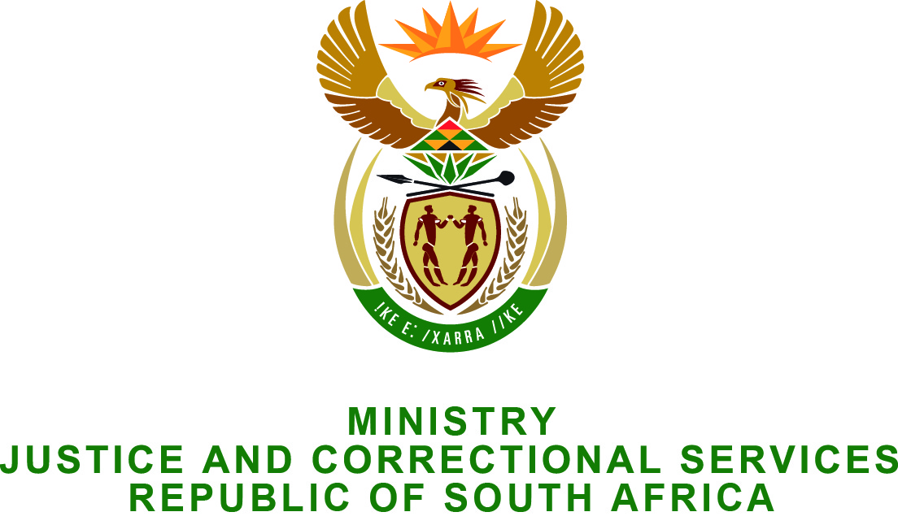

NATIONAL ASSEMBLY
QUESTION FOR WRITTEN REPLY
PARLIAMENTARY QUESTION NO: 2347
DATE OF QUESTION: 19 JUNE 2015
DATE OF SUBMISSION: 26 JUNE 2015

Adv G Breytenbach (DA) to ask the Minister of Justice and Correctional Services:
Whether the Chief Justice undertook any international trips in the (a) 2014-15 financial year and (b) from 1 April 2015 up to the latest specified date for which information is available; if so, (i) to which countries, (ii)(aa) how many persons formed part of the Chief Justice’s delegation and (bb) what is their official designation and (iii) what class of (aa) transport and (bb) accommodation was utilised for each person forming part of the delegation?

Answer:
- Yes.

- Yes.

2014 / 2015 Financial year:

The Chief Justice of the Republic of South Africa is, in accordance with section 165 of the Constitution, the Head of the Judiciary, an independent arm of the State and by virtue of his position, receives invitations from various international judicial bodies which he sometimes has to honour. Additionally, the Chief Justice is also one of the Vice-Presidents of the Conference of Constitutional Jurisdictions of Africa, a body comprising 34 members of Constitutional Courts and Constitutional Councils in Africa, established to promote constitutional justice within the Continent and responsible for ensuring compliance with the Constitution. He is also a member of the Southern African Chief Justices’ Forum, a body comprising of all the Chief Justices in the Southern and East Africa intended to deal with issues affecting the Judiciary in the SADC region. The Constitutional Court of the Republic of South Africa is also a member of the World Conference on Constitutional Justice comprising of 71 Constitutional Courts, Councils and Supreme Courts, with the aim of promoting constitutional justice.

(i) Turkey

In April 2014, the Chief Justice attended the 2nd Congress of the Asian Constitutional Courts and Equivalent Institutions, and the 52nd Anniversary of the Constitutional Court of Turkey, in his capacity as the Vice-President of the Conference of Constitutional Jurisdictions of Africa which was held in Instanbul, Turkey, at the invitation of the President of the Turkish Constitutional Court. The Chief Justice gave a speech at the conference and also chaired a session on “The Role of the Constitutional and Supreme Courts in the Protection of Constitutional Order”.
(ii) (aa) Four.
(bb) Chief Justice’s Spouse; Acting Head: Judicial Policy, Research and JSC; Acting Director: Executive Support Services; and the Security Coordinator.

(i) Nigeria

In July 2014, the Chief Justice attended and addressed a Judicial Reforms Conference at the invitation of the President of the Nigerian Bar Association which was held in Abuja, Nigeria.
(ii) (aa) Five.
(bb) Chief Justice’s Spouse; Acting Head: Judicial Policy, Research and JSC; Director: Executive Support Services; Executive Personal Assistant to the Chief Justice; and the Security Coordinator.
(i) Zambia

In September 2014, the Chief Justice attended the Annual General Meeting of the Southern African Chief Justices’ Forum at the invitation of the acting Chief Justice of Zambia.
(ii) (aa) Four.
(bb) Chief Justice’s Spouse; Acting Head: Judicial Policy, Research and JSC; Director: Executive Support Services; and the Protocol Coordinator.

(i) South Korea

In September 2014, the Chief Justice attended the 3rd Congress of the World Conference on Constitutional Justice of which the Constitutional Court of the Republic of South Africa is a member, at the invitation of the President of the Constitutional Court of the Republic of South Korea and the President of the Venice Commission. The Chief Justice chaired a session and gave remarks on “Constitutional Instruments Enhancing / Dealing with / for Social Integration.
- (aa) Four.
(bb) Chief Justice’s Spouse; Acting Head: Judicial Policy, Research and JSC; Director: Executive Support Services; and the Security Coordinator.

(i) United Kingdom

In October 2014, the Chief Justice attended the Opening of the Legal Year in England and Wales at the invitation of the Lord Chancellor and Secretary of State for Justice of the Ministry of Justice of the United Kingdom.
- (aa) Four.
(bb) Chief Justice’s Spouse; Acting Head: Judicial Policy, Research and JSC; Director: Executive Support Services; and the Security Coordinator.

(i) Singapore

In October 2014, the Chief Justice went to Singapore and delivered a Lecture on “Twenty Years of the South African Constitution – Origins, Aspirations and Delivery” to the Singapore Academy of Law at the invitation of the Chief Justice of Singapore and President of the Singapore Academy of Law. The Office of the Chief Justice in Singapore paid for the air travel and accommodation for the Chief Justice of the Republic of South Africa and his Spouse.
- (aa) Four.
(bb) Chief Justice’s Spouse; Director: Executive Support Services; Executive Personal Assistant; and the Security Coordinator.

(i) Swaziland

In November 2014, the Chief Justice was requested by the Executive Committee of the SADC Lawyers Association, International Commission of Jurists and the Justices of the Constitutional Court of the Republic of South Africa to discuss concerns regarding the Swaziland Judiciary.
- (aa) Two.
(bb) Director: Executive Support Services and the Security Coordinator.

(i) Mozambique

In February 2015, the Chief Justice attended the Fifth Session of the Executive Bureau of the Conference of Constitutional Jurisdictions of Africa (CCJA) as Vice President of the CCJA, at the invitation of the President of the CCJA.
- (aa) Four.
(bb) Chief Justice’s Spouse; Acting Head: Judicial Policy, Research and JSC; Director: Executive Support Services and the Security Coordinator.

(i) United Kingdom

In February 2015, the Chief Justice attended and addressed the Global Law Summit marking the 800th Anniversary of the Magna Carta at the invitation of the Ministry of Justice of the United Kingdom.
- (aa) Three
(bb) Director: Executive Support Services; Protocol Coordinator; the Security Coordinator.

The following is applicable to all the official visits abroad for the 2014 / 2015 financial year as listed above:

- (aa) The Director-General of the Department of Justice and Constitutional Development, in consultation with the Secretary-General of the Office of the Chief Justice, approved that the relevant officials may use air travel in business class to render the required in transit close proximity support to the Chief Justice as provided for in paragraph 3.2 of the Handbook for Members of the Executive and Presiding Officers, the “Ministerial handbook”. The Office of the Chief Justice uses the Ministerial Handbook as a guide in the absence of an approved handbook for the Judiciary. The referred paragraph stipulates as follows: “In cases where Members perform official functions by virtue of their office, and where this is in their opinion warranted, a member (or members, as the nature of the official duty prescribe) of the Private Office staff may accompany them and stay in the same hostelry and travel in the same class at Government expense”.
(bb) To enable the members of the delegation to render close proximity support to the Chief Justice whilst in the foreign country and in keeping with the provisions of paragraph 3.2 of the Ministerial handbook as quoted in paragraph (iii) (aa) above, the Director-General of the Department of Justice and Constitutional Development, in consultation with the Secretary-General of the Office of the Chief Justice, approved that the delegation use the same accommodation as the Chief Justice.

2015 / 2016 Financial year

(i) Republic of Gabon

In May 2015, the Chief Justice attended the Third Congress of the Conference of Constitutional Jurisdictions of Africa (CCJA) in his capacity as Vice President of the CCJA, at the invitation of the President of the CCJA. The Chief Justice chaired a session on the “The Synthesis of Responses to the Questionnaire by the Anglophone Constitutional Courts and Councils.”
- (aa) Four.
(bb) Chief Justice’s Spouse; Acting Head: Judicial Policy, Research and JSC; Director: Executive Support Services; and the Security Coordinator.

- (aa) The Secretary-General of the Office of the Chief Justice, approved that the relevant officials may use air travel in business class to render the required in transit close proximity support to the Chief Justice as provided for in paragraph 3.2 of the Handbook for Members of the Executive and Presiding Officers, the “Ministerial handbook”. The Office of the Chief Justice uses the Ministerial Handbook as a guide in the absence of an approved handbook for the Judiciary. The referred paragraph stipulates as follows: “In cases where Members perform official functions by virtue of their office, and where this is in their opinion warranted, a member (or members, as the nature of the official duty prescribe) of the Private Office staff may accompany them and stay in the same hostelry and travel in the same class at Government expense”.
(bb) To enable the members of the delegation to render close proximity support to the Chief Justice whilst in the foreign country and in keeping with the provisions of paragraph 3.2 of the Ministerial handbook as quoted in paragraph (iii) (aa) above, the Secretary-General of the Office of the Chief Justice, approved that the delegation use the same accommodation as the Chief Justice.

