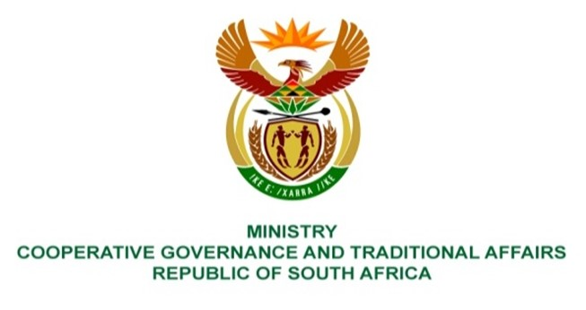

NATIONAL ASSEMBLY
QUESTION FOR WRITTEN REPLY

QUESTION NUMBER 234
DATE OF PUBLICATION: 10 FEBRUARY 2022

QUESTION:

234. Mr K Ceza (EFF) to ask the Minister of Cooperative Governance and Traditional Affairs:
Whether there is a system in place to sort out the mess created by the Municipal Demarcation Board in terms of the election of ward committees, given the nature of pre-local government elections delimitation of wards, wherein many residents were not voting in their wards of residence; if not, why not; if so, what are the relevant details? NW241E

REPLY:

The Municipal Demarcation Board is responsible for delimiting metropolitan and local municipalities into wards, a Councillor representing a ward is elected by the voters registered in that specific ward. The finalisation of ward boundaries was informed by a comprehensive public participation and consultative process that was undertaken by the MDB, and the number of wards in the country increased from 4,392 in 2016 to 4,468 in 2021.
In terms of Section 73 of the Municipal Structures Act (as amended), metropolitan and local municipalities must establish ward committees within 120 days after the election of a municipal council. If the ward committee is not established within the 120 days, the Speaker must request the MEC for an extension. Section 73(3) of the Act requires metropolitan and local municipalities to make rules regulating the procedure to elect members of ward committees, taking into account the need to for women to be equitably represented in the committee and for a diversity of interests in the ward to be represented.
The Department is currently monitoring the establishment of ward committees in all metropolitan and local municipalities across the country.

