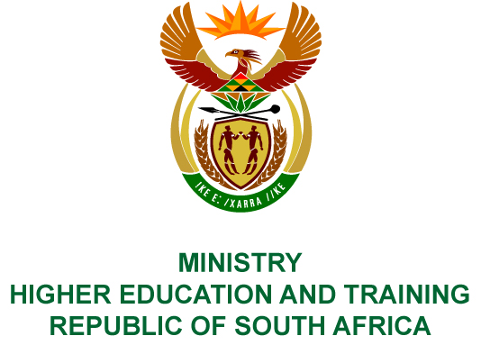
Private Bag X893, Pretoria, 0001, Tel (012) 312 5555, Fax (012) 323 5618
Private Bag X9192, Cape Town, 8000, Tel (021) 469 5150, Fax: (021) 465 7956
Memorandum from the Parliamentary Office
NATIONAL ASSEMBLY
FOR WRITTEN REPLY
QUESTION 234
DATE OF PUBLICATION OF INTERNAL QUESTION PAPER: 16/02/2018

(INTERNAL QUESTION PAPER NO 2 OF 2018)
Mr L G Mokoena (EFF) to ask the Minister of Higher Education and Training:
(1) With reference to projects that have been funded under the Humanities Hubs Programme of the National Institute for Humanities and Social Sciences in the period 1 January 2009 to 31 December 2017, (a) who was the (i) signatory and/or approver of each project, (b) what (i) was the output and budget of each project, (ii) amount has been paid in respect of each project in each year for which payments have been made, (iii) amount still needs to be paid and (iv) is the total cost for each project;
(2) Whether all projects comply with cost-cutting measures and regulations of the National Treasury and the Auditor-General of South Africa?
NW255E

REPLY:
The National Institute for Humanities and Social Sciences (NIHSS) has provided the following responses to the questions posed.
 |  |  | (1) (b) (i) | (1) (b) (ii) | (1) (b) (iii) | (1) (b) (iv) | (1) (a) (i)
 | Name of Project | Funding Period | Output and Budget | Amount paid | Amount still to be paid | Total Cost | Name of approver /signatory
 | Liberation Struggle Histories Hub | 01/08/2014 – 31/08/2017 | Colloquium; Schools outreach; Mobile exhibition at UNISA, UL and UNIVEN  R2 212 766 | R2 162 766 | R50 000 | R2 212 766 | Prof Sarah Mosoetsa
 | Freedom and Humanity Hub | 01/04/2017 – 31/03/2018 | Conduct educational programme 2. host story telling / oral history performance 3. Establish Pan African Archives 4. Collaborate with the University of Sol Plaatje, University of South African and University of Mpumalanga  R 3 000 000 | R3 000 000 | R0 | R3 000 000 | Prof Sarah Mosoetsa
 | Community Based Memories Humanities Hub | 01/04/2017 – 31/03/2020 | Digitize the following Hubs and sites: Lwandle Museum, Alice Community Museum, Hogsback Community Art Gallery, Mgwali Forced Removal Community Museum, Legal Offices of Robert Sobukwe in Graaf Reinet, Home of Steve Biko, Ginsberg, Z.K. Matthews House, Alice  R2 208 700 | R1 104 350 | R1 104 350 | R2 208 700 | Prof Sarah Mosoetsa
 | Isimangaliso Humanities Hub | 01/04/2017 – 31/03/2018 | Development of Digital Archive; 2. Publication of edited volume 3. Publication of journal articles 4. Capacity building, particularly for designated groups  R1 058 000 | R529 000 | R529 000 | R1 058 000 | Prof Sarah Mosoetsa
 | Migrant Workers' Humanities Hub | 01/04/2017 – 31/03/2019 | Conduct a travelling exhibition 2. Produce a DVD or booklet on the museum 3. Collaborate with Kuyakhanya Production, University of Fort Hare and University of KwaZulu-Natal  R1 241 000 | R710 500 | R530 500 | R1 241 000 | Prof Sarah Mosoetsa
 | Mapungubwe Cultural Humanities Hub | 01/04/2017 – 31/03/2018 | Host a conference 2. Host a Dialogue 3. Capacity building particularly for designated racial and gender groups  R3 000 000 | R1 500 000 | R1 500 000 | R3 000 000 | Prof Sarah Mosoetsa
 | Land and Intellectual Humanities Hub | 01/04/2017 – 31/03/2018 | The project will yield the following:  - Colloquium proceedings and two journal articles or chapters in books arising out of the colloquium  - Fifteen recorded accounts of the educational histories and experiences in the Eastern Cape of individual participants and their families  - Produce a documentary film based on these recorded histories  - An archive (video recordings and transcribed documents) of at least six recorded interviews with local people about their family’s history with regard to land  R3 000 000 | R0 | R3 000 000 | R3 000 000 | Prof Sarah Mosoetsa
 | Origins Humanities Hub | 01/04/2017 – 31/03/2018 | Installation of Engraved Boulders:  - Coordinate public visits  - Host Workshops  - Procure educational materials  On Reflection of the contribution of Africa to world civilisations:  - Update Blombos exhibition and Middle Age fossil discoveries on the Cape Coast  - Conduct community workshop  - Conduct Education seminar  R1 500 000 | R750 000 | R750 000 | R1 500 000 | Prof Sarah Mosoetsa

- The expenditure complied with the NIHSS’s policies. The NIHSS is neither a Department, nor a constitutional institution, nor a public entity listed in Schedule 2 or 3, and therefore the Public Finance Management Act is not applicable to the NIHSS.
The Auditor-General of South Africa audits the NIHSS in terms of Section 38 of the Higher Education Act and since its inception has received unqualified audit opinions.

