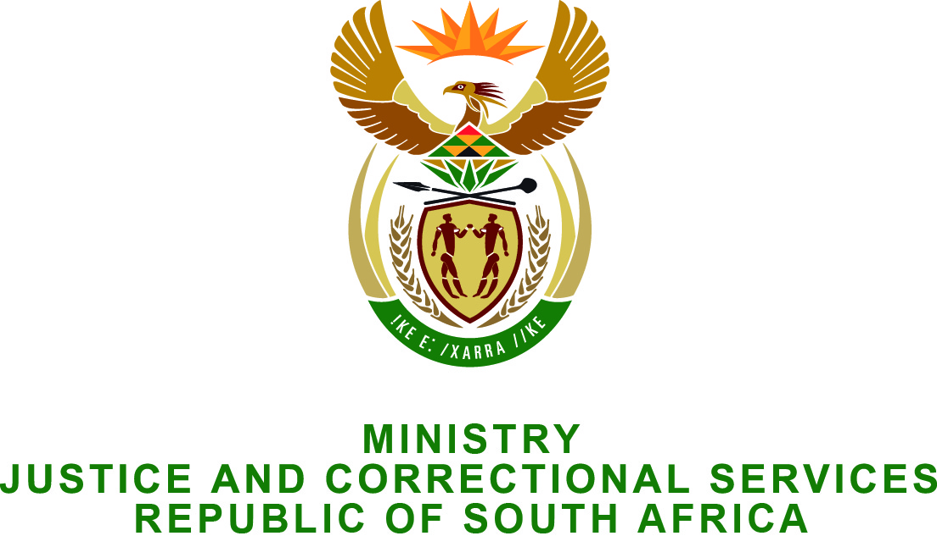

PARLIAMENT OF THE REPUBLIC OF SOUTH AFRICA
NATIONAL ASSEMBLY

FOR WRITTEN REPLY

QUESTION NO: 2339

Mr J Selfe (DA) to ask the Minister of Justice and Correctional Services:

Whether parole has been approved to a certain person (name and details furnished); if not, what are the relevant details? NW2700E

REPLY:

No, parole has not been approved for the mentioned offender. He was sentenced to life imprisonment on 22 October 1999 for Robbery x 4; Rape x 2; attempted murder; assault grievous bodily harm (GBH); attempted escape x 2; housebreaking with intent to rob and robbery with aggravating circumstances; housebreaking with intent to steal; theft; unlawful possession of fire-arm x 5 and unlawful possession of ammunition x 3.

The offender was considered by the Minister of Correctional Services on 11 October 2013 for possible placement on parole. The Minister decided that the offender should be reconsidered during October 2015. During this period, the following should inter alia be addressed:

- Offender needs to undergo individual Psychotherapy in order to address his anger towards females and needs to attend counselling sessions to address parental guidance and communication styles.
- A copy of the judgement on conviction and sentence be obtained.
- The profile reports of the accomplices of the offender should be subjoined to the National Council for Correctional Services and Minister during October 2015.

