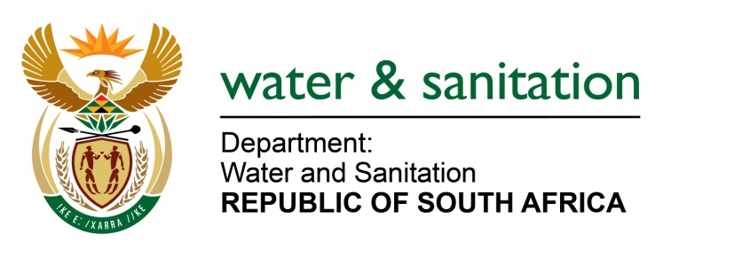

NATIONAL ASSEMBLY

FOR WRITTEN REPLY

QUESTION NO 2335

DATE OF PUBLICATION IN INTERNAL QUESTION PAPER: 17 JUNE 2022
(INTERNAL QUESTION PAPER NO. 24)

2335. Mr I M Groenewald (FF Plus) to ask the Minister of Water and Sanitation:
(1) Whether, with reference to his department’s statement in its report to the Portfolio Committee on Water and Sanitation on 6 June 2022, that all municipalities whose waste water plants are in a critical condition of dysfunction were instructed to submit turnaround plans within 60 days after the publication of the Green Drop Report, he will indicate the total number of municipalities that were instructed to submit turnaround plans; if not, why not; if so, what total number of municipalities (a) did comply and/or (b) did not comply with the specified instruction;
(2) whether he will make a statement on the matter?
NW2756E
---00O00---

MINISTER OF WATER AND SANITATION

- A total of 90 Water Service Authorities responsible for 334 wastewater collection and treatment systems that achieved less than 30% during the Department’s Green Drop Assessment were issued with non-compliance letters and instructed to prepare and submit corrective action plans as highlighted in the Green Drop 2022 Report.

- Six (6) of the Water Services Authorities have complied and submitted action plans which are currently being considered by the Department as follows:
  - Joe Morolong LM
  - Ndlambe LM
  - Koukamma LM
  - Hessequa LM
  - Alfren Nzo DM
  - Langeberg LM

Two (2) Water Service Authorities indicated below have requested and granted additional time to develop action plans:
  - Emthanjeni LM
  - Dipaleseng LM

A further five (5) Water Services Authorities did not provide action plans but requested support from DWS as follows:

  - Dr Beyers Naude LM
  - Siyancuma LM
  - Zululand DM
  - Khai Ma LM
  - Blue Crane LM

- Seventy-seven (77) Water Services Authorities did not adhere to their non-compliance letter issued.

---00O00---

