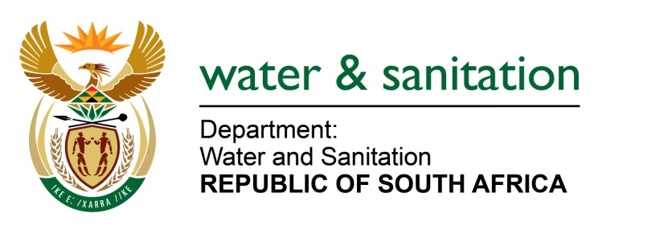

NATIONAL ASSEMBLY

FOR WRITTEN REPLY

QUESTION NO 2334

DATE OF PUBLICATION IN INTERNAL QUESTION PAPER: 19 JUNE 2015
(INTERNAL QUESTION PAPER NO. 22)

2334. Mr A R McLoughlin (DA) to ask the Minister of Water and Sanitation:

(1) What is the current status of the Sedibeng Regional Sewerage Scheme (SRSS);

(2) (a) what factors are currently holding up the implementation of the SRSS and (b) what steps are being taken to resolve these hold-ups;

(3) when is the SRSS expected to become operational and (b) what interim measures are currently in place in the Southern Gauteng region to limit the impact on development in each affected municipality;

(4) who is the current implementing agent of the SRSS? NW2695E

---00O00---
REPLY:

- The Sedibeng Regional Sanitation Scheme (SRSS) comprises construction upgrade of the following works:

- The Sebokeng Wastewater Treatment Works (WWTW) upgrade – construction started in August 2013, Progress for these works is at 35% complete on civil works;
- The Meyerton WWTW upgrade – construction started in March 2015 and construction work is progressing very well. Currently, progress for the civil contractor is around 8% complete; and
- The feasibility studies for the proposed 150 mega-litres Regional WWTW has started in April 2015 and expected to be completed by November 2015. The Implementation Readiness Studies and Preliminary designs are expected to be completed by April 2016.

(2)(a) The source of delays in the implementation of the entire SRSS were as a result of the change of the Implementation Agent (IA) from the Municipalities (Emfuleni and Midvaal LMs) to Rand Water and secondly, the legal process to cede the service providers from the LMs to Rand Water. However, some of the professional service providers ceding processes experienced legal changes, this involved the Supervising Engineer for the SRSS, which ended up at High Court and subsequently resolved in an out of court settlement.

(2)(b) All the legal processes have been completed and work is currently being undertaken as mentioned in paragraph 1 above.

(3)(a) The implementation of the SRSS will take between 5 to 7 years to complete.

(3)(b) Additional development in both Midvaal and Sebokeng will be connected to both Meyerton WWTW and Sebokeng WWTW, which are being upgraded. Outfall sewer lines are included as part of scope to connect new developments such as Savanna City.

(4) Rand Water is appointed as the IA by the Minister of Water and Sanitation.

---00O00---

