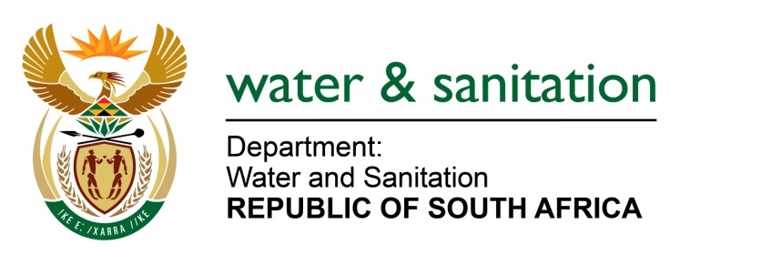

NATIONAL ASSEMBLY

FOR WRITTEN REPLY

QUESTION NO 2330

DATE OF PUBLICATION IN INTERNAL QUESTION PAPER: 19 JUNE 2015
(INTERNAL QUESTION PAPER NO. 22)

2330. Mrs Z B N Balindlela (DA) to ask the Minister of Water and Sanitation:

Whether, with reference to the Eskom Ingula Pumped Storage Scheme in the (a) Ladysmith district of KwaZulu-Natal and (b) Harrismith district of the Free State, her department has done any investigations to ascertain the impact of the specified scheme on the Wilge River and Vaal River catchment area which has been affected and/or will be affected by the resettlement of persons resident on the project sites by Eskom; if not, why not; if so, what are the (i) relevant details of completed assessments and (ii) outcomes of the assessments? NW2691E
---00O00---
REPLY:
The Environmental Impact Assessment (EIA) of Eskom Ingula Pumped Storage Scheme was the responsibility of Eskom and the Department of Water and Sanitation (DWS) participated therein. The Department is not aware of any significant impacts on Wilge and Vaal Rivers.
The resettlement of communities was also part of the same process and thus no undue impacts are anticipated.
The Department issued Water Use Licenses for the project and will continue to monitor compliance to the license conditions.
---00O00---

