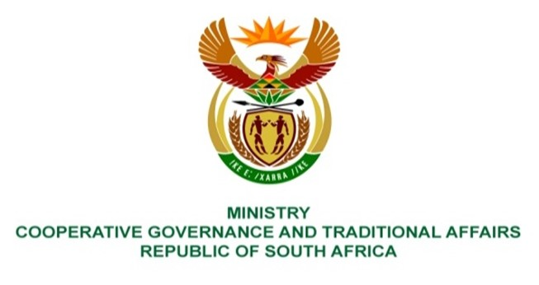

NATIONAL ASSEMBLY
QUESTIONS FOR WRITTEN REPLY

QUESTION NUMBER 233
DATE OF PUBLICATION: 10 FEBRUARY 2022

QUESTION:

233. Mr K Ceza (EFF) to ask the Minister of Cooperative Governance and Traditional Affairs:
What action has been taken against the (a) Municipal Manager of the Amathole District Municipality and (b) security company whose security guards unleashed violence on Councillor Nanziwe Rulashe at the offices of the specified municipality? NW240E

REPLY:
The Amathole District Municipality has appointed an independent panel to investigate the matter and to submit the report to Council. I have requested the Municipality and MEC of COGTA to furnish me with the report, and I will update the response as soon as it is rceived.

BACKGROUND INFORMATION:

