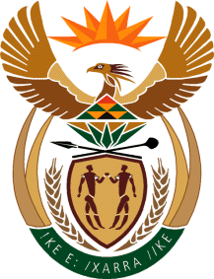

MINISTRY OF TOURISM
REPUBLIC OF SOUTH AFRICA

Private Bag X424, Pretoria, 0001, South Africa. Tel. (+27 12) 444 6780, Fax (+27 12) 444 7027
Private Bag X9154, Cape Town, 8000, South Africa. Tel. (+27 21) 469 5800, Fax: (+27 21) 465 3216

NATIONAL ASSEMBLY:

QUESTION FOR WRITTEN REPLY:
Question Number: 2328
Date of Publication: 9 June 2023
NCOP IQP Number: 23
Date of reply: 16 June 2023

Mr K P Sithole (IFP) to ask the Minister of Tourism:
Given that besides stringent visa processes, crime is another barrier standing in the way of tourist attraction over the past few years, especially in destinations such as Mpumalanga which has seen a rise in tourist hijackings recently, what steps has her department taken to (a) ensure tourist safety and (b) convince tourists that the specified hijackings were isolated incidents and not a common occurrence, in order to encourage tourism in the specified province? NW2645E

REPLY:

- Tourism is a concurrent function in the Constitution.

The Department together with provinces, the private sector and law enforcement agencies developed a Tourism Safety Strategy in 2018. The 2018 Strategy has not yet been fully implemented and was revisited on 29 May 2023 at a Dialogue to implement it and action was agreed on outstanding issues. The strategy implementation is supported by a Memorandum of Understanding (MoU) between the Department and SAPS.
The Tourism Safety Forum will now meet quarterly.
The Department has budgeted to train 2000 Tourism Monitors in the 2023/24 Financial Year.

(b) In partnership with the private sector, we will launch a safety app and operational centre where monitoring will be done.

