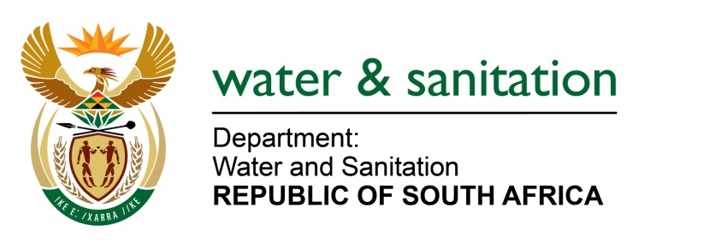

NATIONAL ASSEMBLY

FOR WRITTEN REPLY

QUESTION NO 2321

DATE OF PUBLICATION IN INTERNAL QUESTION PAPER: 10 JUNE 2022
(INTERNAL QUESTION PAPER NO. 23)

2321. Mrs S M Mokgotho (EFF) to ask the Minister of Water and Sanitation:
On what date is it envisaged that sufficient bulk water and sanitation will be provided to residents of Matlapeng in the Kagisano-Molopo Local Municipality, who currently receive their water from trucks which deliver water once every three weeks?
NW2740E

---00O00---
MINISTER OF WATER AND SANITATION
The Tlapeng village is currently receiving water supply through tankering and three (3) existing boreholes. The existing boreholes are unable to cater for the demand in the village. The boreholes discharge an average of 2l/s instead 3.5 l/s which is needed to meet the current demand of approximately 2900 people being serviced at RDP standards.
To address the challenge of water provision and meet the demand for water supply the following plans are to be implemented:
- A professional service provider has been appointed to do the investigation and designs for construction project of a bulk water scheme.
- The preliminary design report will be presented to the Department in August 2022 and the final detailed design report will be tabled in September 2022
- Tender documents will be prepared by November 2022
- The plan is to commence with construction in January 2023 for a period of 18 months
Should the study meet all the requirements, the Department of Water and Sanitation will avail funding under the Regional Bulk Infrastructure Grant for the implementation of Tlapeng Cluster Water Supply System.

---00O00---

