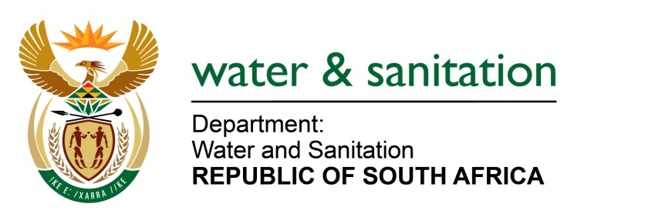

NATIONAL ASSEMBLY

FOR WRITTEN REPLY

QUESTION NO 2316

DATE OF PUBLICATION IN INTERNAL QUESTION PAPER: 12 JUNE 2015
(INTERNAL QUESTION PAPER NO. 21)

2316. Mr M H Redelinghuys (DA) to ask the Minister of Water and Sanitation:
(1) Whether her department has had any engagement with the City of Tshwane regarding (a) a dam in Midas, Mabopane, Ward 22 and (b)(i) health, (ii) safety and (iii) environmental risks associated with the specified dam;
(2) whether her department will conduct a health and safety assessment in respect of the specified dam;
(3) whether her department intends to engage with the municipality to address the safety concerns of the local community? NW2678E
---00O00---
REPLY:

(1) The Department of Water and Sanitation had no previous engagements with the City of Tshwane regarding health, safety or environmental risk of a dam in Midas.

(2) No complaints about the query have been received by my Department and no health and safety assessment was therefore planned.

(3) Yes, my Department has engaged with the City of Tshwane municipality regarding this issue and met incidentally with a community leader on 18 June 2015 during the site visit. According to the representative of the community, they get their services from the City of Tshwane. Madibeng Municipality will also be approached through my sector support unit to address the matter further.

---00O00---

