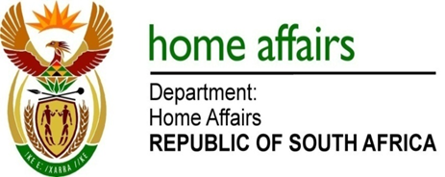

NATIONAL ASSEMBLY

QUESTION FOR WRITTEN REPLY

QUESTION NO. 2315

DATE OF PUBLICATION: MONDAY, 14 AUGUST 2017

INTERNAL QUESTION PAPER 26 OF 2017

2315. Mr M W Rabotapi (DA) to ask the Minister of Home Affairs:

With reference to his reply to question 1758 on 12 July 2017, (a) what is the total monthly expenditure for the internal security officer protecting the Head of the Department of Home Affairs, including (i) salary, (ii) benefits, (iii) over-time payment, (iv) incidentals and (v) other costs, (b) on what date was the threat and risk analysis conducted and (c) how often is the situation reviewed? NW2560E
REPLY:

(a) The total monthly expenditure for the internal security officer protecting the Head of the Department of Home Affairs is R48 869.09, including:

(i) Salary, [R36 385.00]
(ii) Benefits, [R4 343.12 (pension)]
(iii) Over-time payment, [R5 960.12]
(iv) Incidentals, [R0.00]
(v) Other costs, [R2 180.85 (standby/role playing allowance)]

(b) The threat and risk analysis was conducted in February 2016.

(c) The situation is reviewed annually, unless a need arises to deviate from the established annual review.

