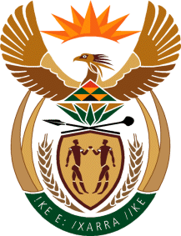

MINISTER IN THE PRESIDENCY: REPUBLIC OF SOUTH AFRICA
Private Bag X1000, Pretoria, 0001, Union Buildings, Government Avenue, PRETORIA
Tel: (012) 300 5200, Website: www.thepresidency.gov.za

NATIONAL ASSEMBLY

QUESTION FOR WRITTEN REPLY

QUESTION NUMBER: 2314

DATE OF PUBLICATIONS: 16 October 2020

2314. Mrs M O Clarke (DA) to ask the Minister in The Presidency:
(1) Whether each national department employs an accounting officer; if not, why not; if so, what are the relevant details;
(2) (a) what number of accounting officers are employed in an acting capacity and (b) does each specified officer have the necessary qualifications required for the position; if not, what is the position in this regard? NW2887E

REPLY:

According to the Public Service Act 103 of 1994, as amended, any information relating to the norms and standards of the Public Service functions, organizational, and governance arrangements, conditions of service and employment practices as well as information Management is the responsibility of the Minister of Public Service and Administration.

Therefore, my colleague, Minister Senzo Mchunu is at the apex of government information on Human Resource employment practices in the Public Service as well as monitoring thereof. I would suggest that this Parliamentary question be re-directed to the relevant institution.

Thank you.

