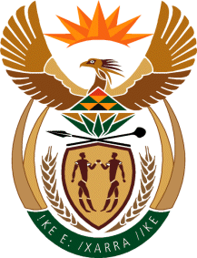

MINISTER IN THE PRESIDENCY: REPUBLIC OF SOUTH AFRICA
Private Bag X1000, Pretoria, 0001, Union Buildings, Government Avenue, PRETORIA
Tel: (012) 300 5200, Website: www.thepresidency.gov.za

NATIONAL ASSEMBLY

QUESTION FOR WRITTEN REPLY

QUESTION NUMBER: 2313

DATE OF PUBLICATIONS: 16 October 2020

2313. Mrs M O Clarke (DA) to ask the Minister in The Presidency:
(1) What (a) total number of directors-general (DGs) in the national departments are currently acting in their positions, (b) is the name of each department in which each specified DG is currently employed;
(2) whether the DGs who are in acting positions have the correct qualifications; if not, in each case (a) what are their names and (b) in what departments are they currently employed; if so, what are the relevant details? NW2886E

REPLY:

According to the Public Service Act 103 of 1994, as amended, any information relating to the norms and standards of the Public Service functions, organizational, and governance arrangements, conditions of service and employment practices as well as information Management is the responsibility of the Minister of Public Service and Administration.

Therefore, my colleague, Minister Senzo Mchunu is at the apex of government information on Human Resource employment practices in the Public Service as well as monitoring thereof. I would suggest that this Parliamentary question be re-directed to the relevant institution.

Thank you.

