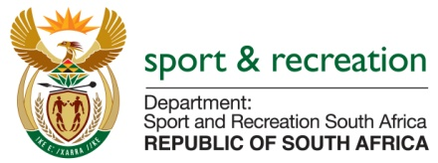

PARLIMENTARY QUESTION FOR THE MINISTER

PARLIAMENTARY QUESTION NUMBER 2072 FOR WRITTEN REPLY IN THE NATIONAL ASSEMBLY

2312. Mr M S Malatsi (DA) to ask the Minister of Sport and Recreation:

Whether any (a) internal and/or (b) external forensic reports pertaining to (i) his department and/or (ii) each entity reporting to him were completed from 1 January 2009 up to the latest specified date for which information is available; if not, in each case, why not; if so, what is the (aa) name, (bb) subject matter and (cc) date of conclusion of each of the specified forensic reports? NW2644E

REPLY
We are still going through the archives searching for this information; the information is not readily available.
(

