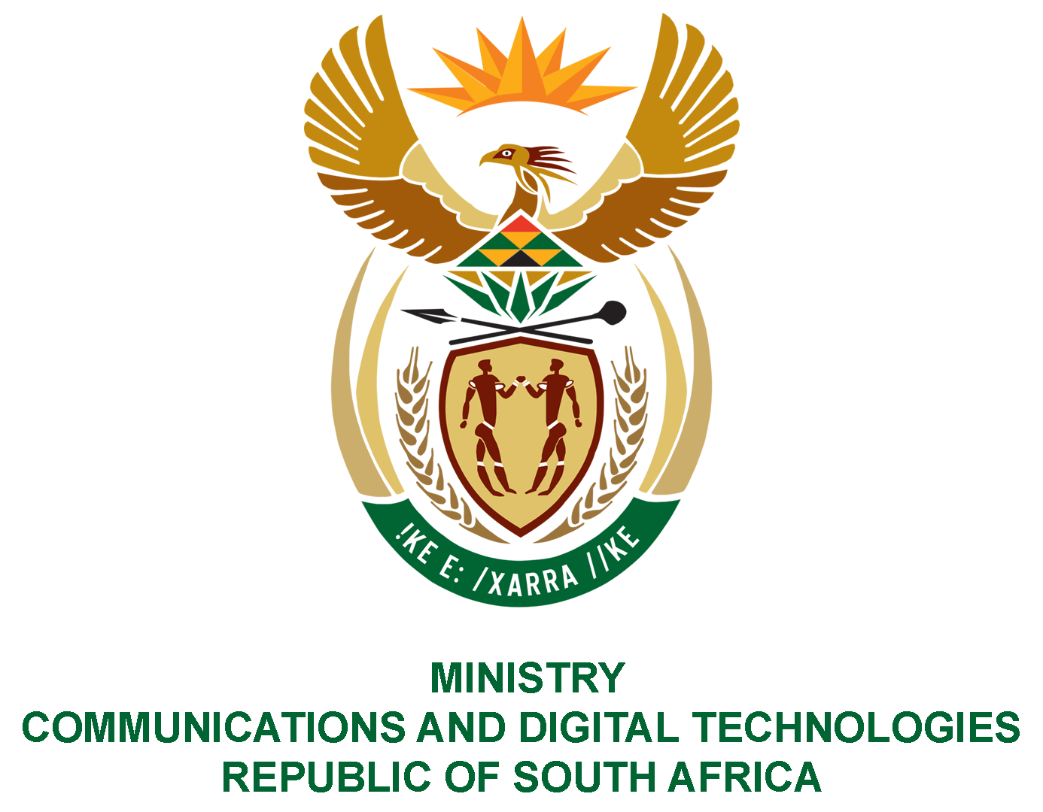

PARLIAMENT OF THE REPUBLIC OF SOUTH AFRICA
NATIONAL ASSEMBLY
WRITTEN REPLY

QUESTION NO: 2311
DATE OF PUBLICATION: 16 October 2020
QUESTION PAPER NO: 38

Ms P van Damme (DA) to ask the Minister of Communications:

- Whether (a) her department and (b) any entities reporting to her paid any bonuses to senior officials in the past two financial years; if so, in each specified case, (i) to whom and (ii) what total amount was paid;
- whether the specified bonuses were performance-based; if not, what is the justification for each bonus; if so, in each case, from which budget were the performance bonuses paid;
- whether, in each case, (a) a performance agreement was signed with the official and (b) regular performance assessments were conducted; if not, why not, in each case; if so, what are the relevant details in each case?
NW2884E

REPLY:
I have been advised by the Department and SOCs as follows:

As stated in the Annual Reports to Parliament for the said financial years regarding the department and entities, the details of the payments are as per the tables below, namely;

Department of Telecommunications and Postal Services
1(a) 2017/18:
 |  | (i)To whom | (ii)Amount Paid
(DTPS)  Senior Managers | Yes, cash bonuses were paid to deserving senior managers in the 2017/18 and 2018/19 financial years | Performance bonuses paid for the 2017/18 financial year  The following senior managers received cash bonuses in the 2017/18 financial year:  - Mr Shelembe O, DDG: ICT Enterprise Development and SOEs Oversight  - Mr Osman F, Chief Director: Strategic Planning and Monitoring  - Advocate Lyons-Grootboom S, Chief Director: Legal  - Ms Maponya C, Director: HRD  - Ms Beukes T, Director: HRA  - Mr Wiltz A, Director: ICT Telecommunication and IT  - Ms Lesufi C, Director: Telecommunications  - Mr Motlatla JL, Information Technology Policy  - Mr Mabuza, Director: Implementation, Monitoring and Evaluation  - Mr Musetha RD, Chief Director: Broadband Infraco  - Mr Sono DA, Chief Director: Radio Frequency Spectrum  - Mr Rabindhnath T, Director: E Skills | The total amount of cash bonuses paid to the senior managers above was R380 565.36 and the budget came from the 1.5% allocated budget from the compensation budget.
2018/2019:
 |  | (i)To whom | (ii)Amount Paid
DTPS |  | Performance bonuses paid for the 2018/19 financial year  The following senior managers received cash bonuses in the 2018/19 financial year:  - Mr Mlambo B, Director: Parliamentary and Cabinet Support  - Ms Sebastian P, Director: Parliament and Cabinet Support  - Mr Mongala S, Director: Risk Management  - Mr Osman F, Chief Director: Strategic Planning and Monitoring  - Mr Maleka SM, Director: Strategic Planning  - Mr Libago J, Director: Monitoring and Evaluation  - Advocate Lyons-Grootboom S, Chief Director: Legal  - Ms Maponya C, Director: HRD  - Ms Masemola JK, CFO  - Ms Motswoenyane E, Director: SCM  - Mr Paterson JG, Director: Organisational Economic Cooperation Development  - Mr Wiltz A, Director: ICT Telecommunication and IT  - Ms Lesufi C, Director: Telecommunications  - Mr Musetha RD, Chief Director: Broadband Infraco  - Mr Gxotiwe S, Director: Broadband Infraco  - Ms Langa R, Chief Director: Postal Sector  - Ms Mandlanga NM, Chief Director: Telecommunications and IT  - Ms Tsolo, P: Director: SOE Governance and Support  - Ms Paul M, Chief Director: ICT Macro and Infrastructure Applications  - Mr Pillay K, Chief Director: Cyber Security Operations  - Ms Duma G, Director: Intergovernmental Coordination  - Ms Mallela P, Director: Stakeholder Relations | The total amount of cash bonuses paid to the senior managers above was R499 660.23 and the budget came from the 1.5% allocated budget from the compensation budget.

- Yes, the bonuses were performance based. The senior managers were found to have performed above what was expected of them in relation to their signed performance agreements in the Moderation Committee meetings and the payment of incentives was approved by the Minister.

3(a) Yes, all senior managers were assessed based on signed performance agreements and performance assessments.
3(b) Yes, all senior managers who received bonuses had mid-term reviews with their supervisors.

Department of Communications
1(a) 2017/2018:-

 |  | (i)To whom | (ii)Amount Paid
Department of Communications (DoC)  Senior Managers | Yes, cash bonuses were paid to deserving senior managers in the 2017/18 and 2018/19 financial years | Performance bonuses paid 2017/18 financial year  The following senior managers received cash bonuses in the 2017/18 financial year:  - Mr Kgarabjang T, Director: Legal Services  - Mr Nieman F, Director: Financial Administration  - Ms Phetla K, Director: Director: Strategic Planning and monitoring | The total amount of cash bonuses paid to the senior managers above was R303 455.68 and the budget came from the 1.5% allocated budget from the compensation budget.

2018/2019:-

 |  | (i)To whom | (ii)Amount Paid
DoC |  | Performance bonuses paid 2018/19 financial year  The following senior managers received cash bonuses in the 2018/19 financial year:  - Mr Kgarabjang T, Director: Legal Services  - Ms Mmushi T, Director: Internal Audit | The total amount of cash bonuses paid to the senior managers above was R163 241.04 and the budget came from the 1.5% allocated budget from the compensation budget.

- Yes, the bonuses were performance based. The senior managers were found to have performed above what was expected of them in relation to their signed performance agreements in the Moderation Committee meetings and the payment of incentives was approved by the Minister.

3(a) All senior managers were assessed based on signed performance agreements and performance assessments.
3(b) Yes, all senior managers who received bonuses had mid-term reviews against their signed PAs with their supervisors.

State Owned Entities
1(b)
Entity | Financial Year | (i)To whom | (ii)Amount Paid
ZADNA | Yes, for FY 2018/19 only | - Mr Peter Madavhu  - Mr Louis Bezuidenhout  - Ms Hendrina Williams
 |  | TOTAL | R93 979.00
SABC | No | N/A | N/A
Film and Publication Board  (FPB) | Yes, for FY 2018/19 | - Unathi Ndobeni
 |  | TOTAL | R79 743.23
Independent Communications Authority of South Africa (ICASA) | Yes, FY 2017/2018 | - Gidi Nkhetheleni Norman  - Sookharan Anneal Kumar  - Ngwepe Willington Alpheus  - Van der Walt Maria Elizabeth  - Nomtshongwana Anele Zandile  - Maina Leah Watetu  - Mngomezulu Portia Busisiwe  - Khumalo Albert Junior  - Kganakga Magobotla Daniel
 |  | TOTAL 2018 | R1 813 700.24
 | Yes, FY 2018/2019 | - Gidi Nkhetheleni Norman  - Sookharan Anneal Kumar  - Ngwepe Willington Alpheus  - Van der Walt Maria Elizabeth  - Nomtshongwana Anele Zandile  - Maina Leah Watetu  - Mngomezulu Portia Busisiwe  - Khumalo Albert Junior  - Kganakga Magobotla Daniel
 |  | TOTAL 2019 | R2 222 738.77
Broadband Infraco (BBI) | No | N/A | N/A
Nemisa | Yes, FY 2018/19 only | - Mr Doc Fick  - Mr Phuthi Phukubje
 |  | TOTAL 2018/19 | R 394 326.00
Sentech | Yes, FY 2017/18 &  FY 2018/19 | - Mr Mlamli Booi  - Mr Tebogo Leshaope  - Mr Siphamandla Mthethwa
 |  | TOTAL 2017/18 FY | R2 192 805.64
 |  | TOTAL 2018/19 FY | R3 250 597.17
State Information Technology Agency (SITA) | Yes, 2018/19 only | - Ms Mimi Le Roux  - Mr Lance Williams  - Mr Sidima Ntsangani  - Mr Ntutule Tshenye  - Mr Ken Weinand  - Ms Makgopolo Mkwanazi  - Mr Setumo Mohapi
 |  | TOTAL | R348 761. 91
Postbank | No | N/A | N/A
USAASA | No | N/A | N/A
SAPO | No | N/A | N/A

2. ZADNA, FPB, ICASA , Nemisa, Sentech, and SITA indicated that the bonuses paid were performance-based. (The question is not applicable to the SABC, BBI, Postbank , USAASA and SAPO as no bonuses were paid during the during the financial years in question)

3(a)&(b) ZADNA, FPB, ICASA, BBI, Nemisa, Sentech and SITA confirmed that performance agreements were signed and regular performance assessments were conducted. (The question is not applicable to the SABC, BBI, Postbank , USAASA and SAPO as no bonuses were paid during the during financial years in question)

MS. STELLA NDABENI-ABRAHAMS, MP
MINISTER OF COMMUNICATIONS AND DIGITAL TECHNOLOGIES

