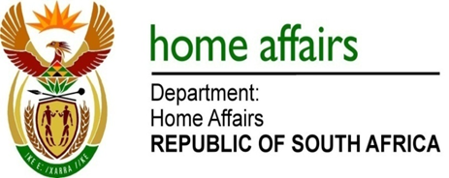

NATIONAL ASSEMBLY

QUESTION FOR WRITTEN REPLY

QUESTION NO. 2310

DATE OF PUBLICATION: MONDAY, 14 AUGUST 2017

INTERNAL QUESTION PAPER 26 OF 2017

2310. Mr M H Hoosen (DA) to ask the Minister of Home Affairs:

(1) Whether the movement control system that tracks the entry and departure of persons who enter the country is currently operating effectively; if not, what are the relevant details of the problems that are being experienced;
(2) is the specified system being managed by her department or the SA Revenue Service;
(3) whether the system has experienced any failures since 1 April 2017 to the extent that her department is unable to detect persons who have overstayed their respective visas; if so, what are the relevant details;
(4) whether her department is capacitated to (a) detect and (b) prevent any fugitives attempting to escape justice from entering the country; if not, what are the relevant details of the specific problems being experienced with the system in this regard; if so, what are the relevant details;
(5) whether (a) her department has access to databases of suspected terrorists and (b) the movement control system is able to prevent any persons appearing in these databases from entering the country; if not, since what date was this weakness detected? NW2555E
REPLY:

- Yes, the Department’s enhanced Movement Control System (EMCS) is
operating effectively.

- The system is currently running on the SARS network platform and is
managed by Home Affairs.

- Since 1 April 2017, no off-line situations on the EMCS at the ports of entry were reported which could have resulted in overstayers not being detected. The Department is able to detect persons that overstay as this is an automated process on the system.

(4)(a-b) Yes the EMCS has a risk engine that accommodates various warning lists in the security cluster.

5(a) The Department does not have access to databases of other institutions.

5(b) Information received on fugitives or international terrorists from other Departments such as the Department of International Relations and Cooperation (DIRCO) or SAPS are flagged and recorded on the Department’s warning lists which run against the Enhanced Movement Control System. The Enhanced Movement Control System is then able to prevent any persons appearing in these databases from entering the country.

