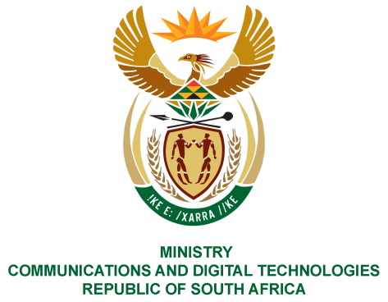
PARLIAMENT OF THE REPUBLIC OF SOUTH AFRICA
NATIONAL ASSEMBLY
WRITTEN REPLY

QUESTION NO: 2309
DATE OF PUBLICATION: OCTOBER 2020
QUESTION PAPER NO:

Ms PT van Damme (DA) to ask the Minister of Communications:

1. With reference to industrial relations of the SA Broadcasting Corporation (SABC), which unions are recognised by the SABC management;
2. whether any other unions have not been recognised by the SABC management; if not, what is the position in this regard; if so, what criteria are used for the recognition of unions;
3. whether the processes in respect of the recognition of unions have been found to be fair and in compliance with the constitutional principles of freedom of association; if not, what is the position in this regard; if so, what are the relevant details? NW2882E

REPLY:

I have been advised by the SABC as follows:
- There are two recognised unions, namely, BEMAWU and Communications Workers Union.
- Prior to its deregistration, MWASA was not recognised by the SABC. MWASA failed to fulfil the 500-membership threshold. The threshold was decided upon through a process of negotiation between the SABC and unions that were seeking recognition within the SABC.
MWASA had a limited organisational rights collective agreement because of its failure to secure the 500-member threshold. MWASA has since been de-registered by the Labour Registrar and thus no longer has a relationship with the SABC.
- SABC believes the collective bargaining process between the parties which preceded the conclusion of the recognition agreements was fair as it culminated in the conclusion of the two recognition agreements with the two unions currently recognised by the SABC which were in line with the applicable provisions of employment law. SABC can confirm that to date neither CWU nor BEMAWU have challenged the fairness or otherwise of the recognition agreement.

MS. STELLA NDABENI-ABRAHAMS, MP
MINISTER OF COMMUNICATIONS AND DIGITAL TECHNOLOGIES

