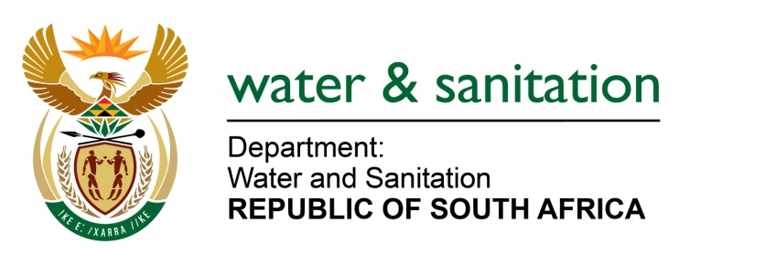

NATIONAL ASSEMBLY

FOR WRITTEN REPLY

QUESTION NO 2307

DATE OF PUBLICATION IN INTERNAL QUESTION PAPER: 14 AUGUST 2017
(INTERNAL QUESTION PAPER NO. 26)
2307. Mr L S Tlhaole (EFF) to ask the Minister of Water and Sanitation:
(a) Given that the previous Blue and Green Drop reports were published in 2013, when will the next Blue Drop and Green Drop reports be published and (b) what action is her department taking to prevent untreated water contaminated with sewage being released from waste water treatment plants in violation of those licences, given that waste water treatment plants are licensed by her department? NW2546E
---00O00---
REPLY:
(a) The next Blue Drop progress assessment report will be finalised by end October and will be published once it is approved. The Green Drop assessment commenced in August 2017 for a self assessment by Municipalities. The report writing will be finalised in April 2018 and report will be published once it is approved.
(b) The Department does regular monitoring of wastewater treatment plants through compliance monitoring and where transgressions are realized Directives are issued to Municipalities and ways are established to turn the situation around. Over and above, the Department also plays a support role by facilitating funding for these wastewater treatment works. The Department also has an enforcement function that work with compliance monitoring section, to ensure that administrative enforcement are enacted once it is observed that despite all the support provided to assist municipalities the situation of non-compliance still persist and only then can legal actions taken.
---00O00---

