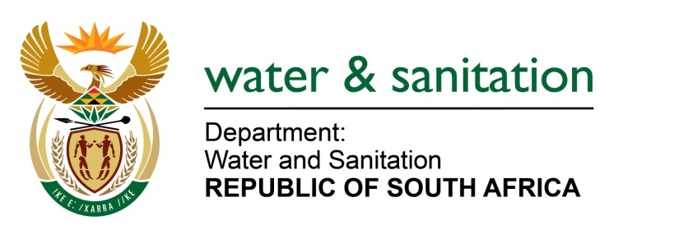

NATIONAL ASSEMBLY

FOR WRITTEN REPLY

QUESTION NO 2306

DATE OF PUBLICATION IN INTERNAL QUESTION PAPER: 14 AUGUST 2017
(INTERNAL QUESTION PAPER NO. 26)
2306. Mr N R Mashabela (EFF) to ask the Minister of Water and Sanitation:
(1) Have any appeals been lodged with her in terms of section 41(6) of the National Water Act, Act 36 of 1998; if not, why not; if so, how many have been (a) lodged and (b) decided;
(2) will the Water Tribunal be retained as an appeal authority in the upcoming draft Water and Sanitation Bill; if not, why not? NW2545E
---00O00---
REPLY:

(1) From 2008 to 2017, a total of 414 appeals have been lodged, and 4 decided; 74 withdrawn by appellants.
(2) No. The reason for discontinuation Water Tribunal is that the Water Tribunal is not an efficient, cost effective and speedy mechanism for the resolution of appeals arising from the implementation of the Act. The new Bill seeks to provide for an administrative dispute resolution mechanism which is more efficient, cost effective, and quicker.
---00O00---

