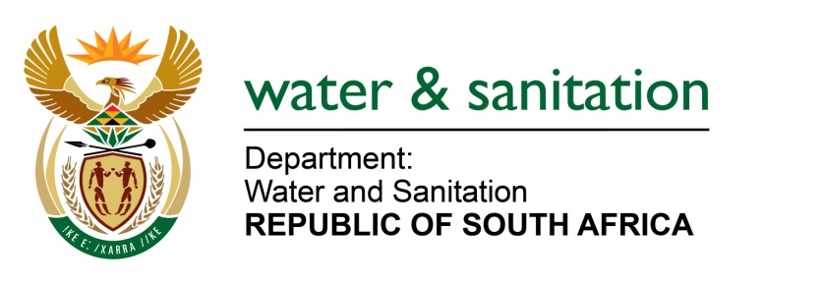

NATIONAL ASSEMBLY

FOR WRITTEN REPLY

QUESTION NO 2305

DATE OF PUBLICATION IN INTERNAL QUESTION PAPER: 05 NOVEMBER 2021

(INTERNAL QUESTION PAPER NO. 23)

2305. Mr N P Masipa (DA) to ask the Minister of Water and Sanitation:

(1) What buildings does his department own in Gauteng?

(2) whether his department has disposed of any of its buildings since 1 April 2020 up to the latest specified date; if not, what is the position in this regard; if so, to whom were the buildings disposed?

NW2623E

---00O00---
MINISTER OF WATER AND SANITATION
- The Water Trading Entity of the Department of Water and Sanitation owns 108 buildings in Gauteng as reflected in the table below:

Area Office | Spatial Locations | Number of buildings
- Bronkhorstspruit Dam | Bronkhorstspruit/ Gauteng | 11
- Roodeplaat Dam on the Pienaars River | Moloto Road/ Gauteng | 60
- Vaal Dam | Springs, Krugersdorp & Germiston | 37
Total |  | 108

- Since 1 April 2020 to date, the department did not dispose-off any buildings.

