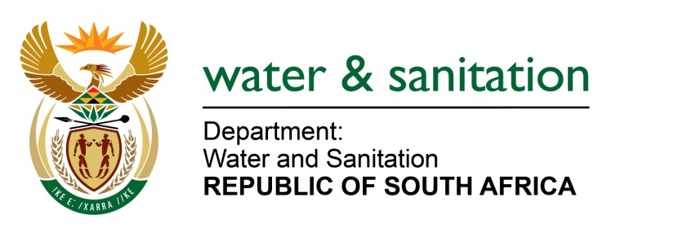

NATIONAL ASSEMBLY

FOR WRITTEN REPLY

QUESTION NO 2305

DATE OF PUBLICATION IN INTERNAL QUESTION PAPER: 14 AUGUST 2017
(INTERNAL QUESTION PAPER NO. 26)
2305. Mr T Rawula (EFF) to ask the Minister of Water and Sanitation:
What factors does she or the person delegated in this regard consider when taking a decision in terms of section 148(2)(b) to uplift the suspension of appeal to the Water Tribunal pending the outcome of such an appeal? NW2544E
---00O00---
REPLY:

The Minister of the Department of Water and Sanitation lifts a suspension of a license pending the outcome of the appeal made to the Water Tribunal when a petition is made indicating any of the following:

- that the granting of all authorisations or a water use licence followed all relevant due processes;
- that the suspension is highly prejudicial and detrimental to a lawfully obtained authorisations;
- that the suspension will derail the entire project timelines and create uncertainties;
- that the suspension will put hundreds of millions of investments at risks as well as forego much needed jobs and community development projects;
- that the issues raised by the Appellants in the appeal should be decided upon by the Water Tribunal, and the Appellants will not be prejudiced by the lifting of the suspension; and
- if the reasons provided by the person who is affected by the suspension are persuasive.
---00O00---

