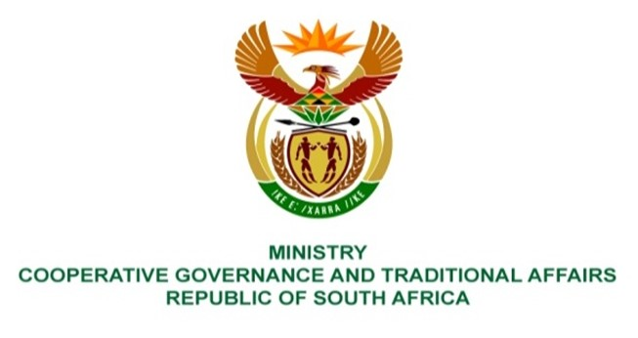

NATIONAL ASSEMBLY
QUESTION FOR WRITTEN

QUESTION NUMBER 2304
DATE OF PUBLICATION: 10 JUNE 2022

QUESTION:

2304. Mr W Horn (DA) to ask the Minister of Cooperative Governance and Traditional Affairs:
With reference to the intervention into the administration and governance of the Mangaung Metropolitan Municipality in terms of section 139(7) of the Constitution of the Republic of South Africa, 1996, what progress has been made to address the failure of the municipality to render basic services in respect of the (a) maintenance of roads and (b) removal of solid waste on a sustainable basis? NW2721E

REPLY:
- Maintenance of Roads
The current road infrastructure network is in a very poor state within the Municipality and maintenance needs to be prioritised. On 02 May 2022, The Acting HOD: Engineering Services commenced his services, and the critical road maintenance areas were identified for urgent attention and priority. Road maintenance is dependent on a fully functioning fleet department within the municipality which is operating at suboptimal level.

Current interventions and priorities on Road Maintenance
The municipality has urgently undertaken roads assessments to identify the critical roads in needs of repairs. These repairs are categorised as pothole repairs and complete re-sealing of critical roads. There are continuous pothole repairs on-going across the metro and re-sealing of roads of estimated 18,8km of length which has started 25 May 2022 and will be complete by end of June 2022. The current benefitting areas are Ward 19(Vista Park), Ward 30(Botshabelo), Ward 31(Botshabelo) and Ward 41(Thaba Nchu). The road maintenance will continue as planned from July 2022 onwards.
(b) Removal of Solid Waste on a sustainability basis (Integrated Waste Management)
Current interventions and priorities
- Maintenance - Southern Landfill site was inaccessible due to the lack of maintenance and illegal dumping around access roads.
- Resources was deployed to clean access roads.
- Law enforcement was deployed to assist with enforcement of illegal dumping around entrances.
- Workers from the Presidential Employment Programme (PEP) were deployed to assist with cleaning.
- The Department of Forestry, Fisheries and Environment has procured the services of a contractor for 12 months to assist on the Southern Landfill site.
- Commencement date of the service provider was 01 June 2022. However, the service provider is not on site yet. The Intervention Team planned meeting with management from the service provider on 16 June 2022 for planning and identification of critical activities.
- Vehicle reallocation from the Southern to Northern site will commence as soon as the service provider is on site to assist with maintenance and operational matters on the Southern site. This will also provide augment maintenance of current fleet that is not operational.
- Fleet assessment -Fleet status quo analysis has been conducted to determine critical fleet that needs urgent attention. As mentioned, the current compactor fleet that deliver domestic waste collection is currently operating at under 40%, that make it impossible to deliver proper domestic waste collection within the Metro.
Key priorities for waste and fleet management in the next 30 days.
- Provide status quo and request support and intervention by the Acting Chief Financial Officer.
- Provide status quo and request support and assistance from National Department of Forestry, Fisheries and Environment for possible assistance regarding Yellow Fleet by:
- Revisit current waste collection practices to streamline service in line with current challenges.
- Development of strategies to strengthen management oversight and accountability and consequence management.
- Standardisation of reporting mechanisms to ward councillors
- Boost and improve morale of workers.
Summary
The success of the intervention as well as the efforts to stabilize the current dysfunctional Waste Management system of the Municipality will and must be supported by proper tools and equipment. The Intervention Team is committed to provide the necessary direction and support to stabilize the current challenges experienced by our communities. Further interaction is urgently needed between Department of Forestry, Fisheries and Environment and National Treasury to investigate measures of support as most of the grand funding resources within the Municipality has been allocated in the 2022/2023 budget.

