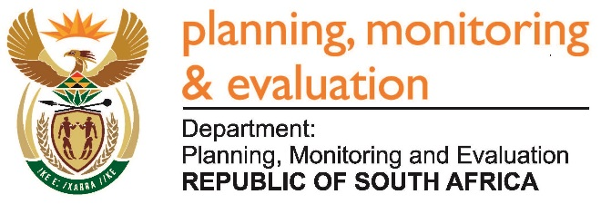 |  | 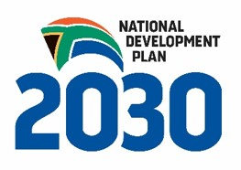
Private Bag X944, PRETORIA, 0001. Union Buildings East Wing, Government Avenue, PRETORIA
Tel: 012 312 0307. www.dpme.gov.za

NATIONAL ASSEMBLY

INTERNAL QUESTION PAPER

2304. Mr T W Mhlongo (DA) to ask the Minister in the Presidency:

Whether any (a) internal and/or (b) external forensic reports pertaining to (i) his department and/or (ii) each entity reporting to him were completed from 1 January 2009 up to the latest specified date for which information is available; if not, in each case, why not; if so, what is the (aa) name, (bb) subject matter and (cc) date of conclusion of each of the specified forensic reports? NW2636E
Reply:
The Department of Planning Monitoring and Evaluation did not have (a) internal or (b) external forensic investigations from the period 1 January 2009 to date. There were no cases that required forensic investigations and therefore there is no (aa) name (bb) subject matter and (cc) date of conclusion of forensic reports.
SekelaXabiso Consulting (Pty) Ltd was appointed by National Treasury on 12 September 2013 to do Forensic Investigation into the tender process and subsequent appointment of the successful bidder pertaining to tender number 12/09 for Statistics South Africa (Stats SA). The response in regard to NYDA is as follows:
Forensic Report - Nature | Internal / External | (aa) Name of the Investigation | (bb) Subject Matter | (cc) Date of Conclusion of the Forensic Report
During the 2011 financial year, an investigation was initiated by the Public Protector to probe whether the hosting of the  World Festival of Youth and Students held in December 2010 had been within the NYDA’s mandate, whether the allocated funds had not been misappropriated and whether the relevant supply chain management prescripts had been followed. | External | World Festival of Youth and Students | Hosting of the  World Festival of Youth and Students event had been within the NYDA’s mandate, whether the allocated funds had not been misappropriated and whether the relevant supply chain management prescripts had been followed. | To date, a final report had not been released by the Public Protector.
Account Payable Manager Fraud | Internal | Account Payable Fraud | Diverting funds to her accounts – fraud detection and funds recovery done. | 30 September 2016  Case closed
Economic Development DJ project | Internal | DJ project | Supply of young DJ’s with DJ equipment, working capital and related branding | 31 December 2013  Case closed
Qualification review | Internal | Qualification Audit | Review of qualification listed on employees CVs | 31 December 2015  Case closed
Fraudulent activity in the Group Lending Programme at the East London Branch Office. The report named two specific group loans (Masiqandane and Khanya Group Loans). | Internal | Group Loan | Fraudulent loan | 05 November 2013  Case closed

