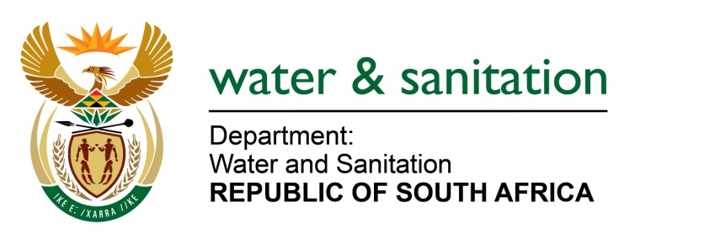

NATIONAL ASSEMBLY

FOR WRITTEN REPLY

QUESTION NO 2304

DATE OF PUBLICATION IN INTERNAL QUESTION PAPER: 12 JUNE 2015
(INTERNAL QUESTION PAPER NO. 21)

2304. Mr L J Basson (DA) to ask the Minister of Water and Sanitation:
Whether, with regard to her department’s report to the Portfolio Committee on Water and Sanitation on 3 June 2015 indicating the required investment in infrastructure over the next 10 years to be at R805 billion and available funding at only R46 billion for each year, her department has a plan in place to fund the R35 billion annual shortfall; if not, how does her department plan on managing the infrastructure; if so, what are the relevant details? NW2665E
---00O00---
REPLY:
Yes, there is a plan to cater for the annual shortfall of R35 billion.
- As part of the development of the Water Sector Infrastructure Investment Framework in 2012, the Department developed a first order Water Financing Strategy published on 5 June 2012.

- In addition, my department has thus far successfully negotiated major increases in the Municipal Infrastructure Grant (MIG) and the Regional Bulk Infrastructure Grant (RBIG), the establishment of a new Municipal Water Infrastructure Grant (MWIG), as well as major increases in the Water Board’s infrastructure investment budgets. This was done in collaboration with the National Treasury as well as the Department of Cooperative Governance and Traditional Affairs, with the aim of increasing budgeting for especially municipal infrastructure operations and maintenance (O&M), addressing aged infrastructure, rehabilitation, and infrastructure replacement.

- Partnerships with Financial Institutions and the broader private sector are also vigorously pursued.

- As a result of financial constraints, there will be on-going prioritization of water supply areas to identify and sequence projects that offer the best economic and social returns and are addressing the most critical security of supply challenges.
---00O00---

