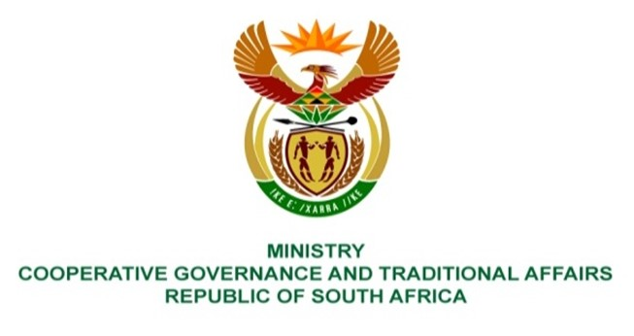

NATIONAL ASSEMBLY
QUESTION FOR WRITTEN

QUESTION NUMBER 2303
DATE OF PUBLICATION: 10 JUNE 2022

QUESTION:

2303. Mr W Horn (DA) to ask the Minister of Cooperative Governance and Traditional Affairs:
With reference to the intervention into the administration and governance of the Mangaung Metropolitan Municipality in terms of section 139(7) of the Constitution of the Republic of South Africa, 1996, what progress has been made in respect of revenue and expenditure management? NW2720E

REPLY:

Revenue Management
As part of revenue raising mechanisms, the Intervention Team will be undertaking stakeholder engagement including Premier’s Office and Public Works to discuss and agree on payment arrangement of outstanding debt owed to the Municipality by government departments.
Regarding disconnection of water services and collections, the Municipality has insufficient institutional capacity and resources to execute disconnections. Therefore, the Intervention Team will source expertise to assist with issuing notices to discontinue services of non-paying consumers failing to conclude payment arrangements with the municipality.
In addition, The Intervention Team is partnering with CENTLEC (municipal entity responsible for electricity reticulation and distribution) by entering Memorandum of Understanding to strengthen coordinate efforts and strategies to collect debt generally owed to the Municipality.
Expenditure Management
The intervention team is implementing corrective measures to reduce excessive overtime and acting allowances that has been paid in the past. These includes enforcing the legislative requirement that pre-approval is to be obtained for any overtime to be worked, limiting the monthly overtime to between 40 - 60 hours per employee where overtime is to be worked and filling of critical vacancies that are funded.
The repairs and maintenance of critical service delivery fleet and equipment is to be prioritized to further alleviate excessive and unauthorized overtime expenditures. This will also by and large significantly reduce the expenditure on contracted services provided there is proper planning, coordination, and control of resources by responsible departments within the city.
The Intervention Team has commenced discussions with Bloemwater on cost of bulk water supply which is unfordable to the Metro. The Metro is in discussions with Bloemwater to review the current outdated service level agreement and review bulk water tariffs. There is a plan to refurbish and upgrade the Masselpoort Water Treatment Plant in the 2022/23 budget year which will diversify the Metro’s sorurces for bulk water supply. The Intervention Team is currently implementing water conservation demand management plan whereby it is envisaging to reduce water losses from 46% to below 20% within the next five years.

