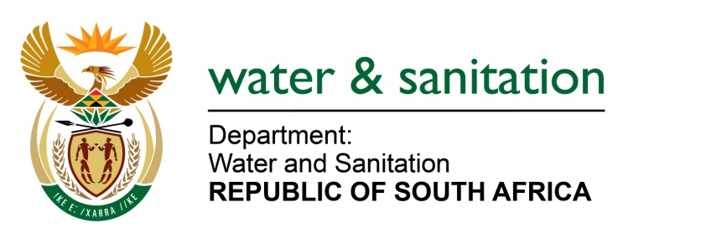

NATIONAL ASSEMBLY

FOR WRITTEN REPLY

QUESTION NO 2303

DATE OF PUBLICATION IN INTERNAL QUESTION PAPER: 12 JUNE 2015
(INTERNAL QUESTION PAPER NO. 21)

2303. Ms L V James (DA) to ask the Minister of Water and Sanitation:
Whether Coal of Africa was granted a water licence for its operations in the (a) Makhado Local Municipality and (b) Musina Local Municipality in Limpopo; if not, why not; if so, (i) on what date was it granted and (ii) what are the terms of the licence agreement? NW2664E
---00O00---
REPLY:

- Coal of Africa was not granted a water licence for its operations in the Makhado Local Municipality. Their water use licence (WUL) application is still being processed by the Department of Water and Sanitation.

(b)(i) Coal of Africa was granted a WUL for its operations in the Musina Local Municipality.

(b)(ii) The water use licence for Coal of Africa in respect of its operations in the Musina Local Municipality was granted on 29 March 2011. The water use licence was granted for a period of five years on the terms stipulated in WUL, which are confidential to the applicant. Coal of Africa plans to continue with the mine, consequently they have applied for another water use licence for the same area covered by the licence granted in 2011.

---00O00---

