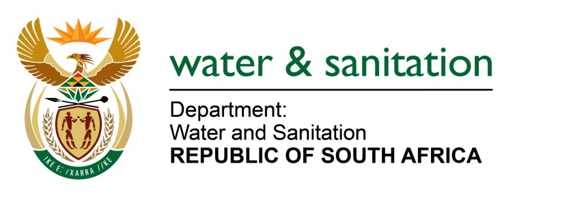

NATIONAL ASSEMBLY

FOR WRITTEN REPLY

QUESTION NO 2299

DATE OF PUBLICATION IN INTERNAL QUESTION PAPER: 12 JUNE 2015
(INTERNAL QUESTION PAPER NO. 21)

2299. Ms T E Baker (DA) to ask the Minister of Water and Sanitation:
Are there any plans in place to release water from the Lesotho Highlands Water Project to assist the Free State towns of Ficksburg, Clocolan and Marquard which have been affected by drought; if not, (a) why not and (b) what other measures have been put into place to deal with the effects of water security resultant from the drought in these communities? NW2660E

---00O00---
REPLY:
Yes, a submission has been made to the Director-General on 21 May 2015 for the release of water from the Katse Dam (Lesotho Highlands Water Project).
(a) Falls away
(b) In order to ensure the sustainability of supply within the system, pumping at the Tienfontein Pump Station (Caledon River) should be maintained. This can only be achieved by releasing water from the Lesotho Highlands Water Scheme (Katse Dam) into the Caledon River. The transfer of water from Knellpoort Dam via the Novo transfer scheme to Rustfontein Dam should also be maintained. Fast-track and intensify the implementation of water conservation and water demand management measures in all affected municipalities. Urgent implementation of the gazetted water restrictions and the monitoring of possible unlawful water use along the Modder River, upstream of Maselspoort Dam.

---00O00---

