DATE OF PUBLICATION IN INTERNAL QUESTION PAPER: 17 AUGUST 2018 (INTERNAL QUESTION PAPER NO 23-2018J

2298. Mr Y Cassim (DA) to ask the Minister of Police:

What is the current status of the investigations into (a) CAS 277/5/2018 and (b) CAS 279/5/2018 which were reported at the Kempton Park Police Station?
NW2475E
REPLY:

- Kempton Park, CAS 277/05/2018 - Assault with the intent to inflict grievous bodily harm. The case was put before the Kempton Park Magistrate’s Court, on 15 August 2018 and has been remanded, to 29 August 2018.

- Kempton Park, CAS 279/05/2018 - Fraud. The alleged suspect in this case is untraceable at this stage. The inVestigating officer will continue to trace the alleged suspect.

Reply to question 2298 recommended/

Date:

CO ONE (SO
2£T8 -£9- # 5
GENERAL
OUTH AFRICAN POLICE SERVICE

36/1/4/1(201800223)
NATIONAL ASSEMBLY
FORWRITTENREPLY
QUESTION 2298
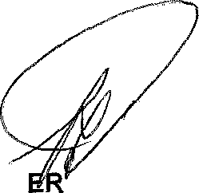
Reply to question 2298 approved/n

MINIST OF POLICE BH CELE, MP

