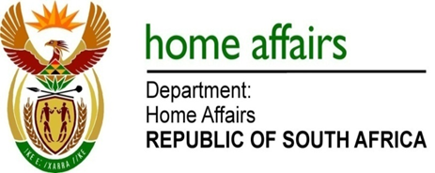

NATIONAL ASSEMBLY

QUESTION FOR WRITTEN REPLY

QUESTION NO. 2297

DATE OF PUBLICATION: Friday, 21 October 2016

INTERNAL QUESTION PAPER 31 OF 2016

2297. Ms N I Tarabella Marchesi (DA) to ask the Minister of Home Affairs:

Whether any (a) internal and/or (b) external forensic reports pertaining to (i) his department and/or (ii) each entity reporting to him were completed from 1 January 2009 up to the latest specified date for which information is available; if not, in each case, why not; if so, what is the (aa) name, (bb) subject matter and (cc) date of conclusion of each of the specified forensic reports? NW2629E
REPLY:

Responses provided by the Department of Home Affairs, Electoral Commission and Government Printing Works are tabulated below:

Department of Home Affairs

 | (aa) - Name | (bb) Subject Matter | (cc) Conclusion date
(a)(i) | 1. Tender DHA22-2013 | Allegations of the alterations of the price after closing date of the tender | 30 June 2015
 | 2. Tender DHA07-2014 | Complaint from member of the public on the awarding of a tender | 24 August 2015
 | 3. Interest on overdue accounts | Interest charged on overdue accounts submitted by Refugee Ministries Centre for interpretation services | 26 September 2016
(a)(ii) | No | N/A | N/A

According to the Electoral Commission

 | (aa) - Name | (bb) Subject Matter | (cc) Conclusion date
(a)(ii) | No | N/A | N/A
(b)(ii) | 1. Forensic Investigation: Electoral Commission – Riverside Office Park | The lease agreement entered into for the Electoral Commission’s national office accommodation | 14 December 2013

According to the Government Printing Works

 | (aa) - Name | (bb) Subject Matter | (cc) Conclusion date
(a)(ii) | 1. Government Printing Works (GPW) | Unauthorised and confidential information shared with external parties relating to the physical security and guarding services tender at GPW Head and Regional Offices | 30 September 2016
(b)(ii) | No | N/A | N/A

