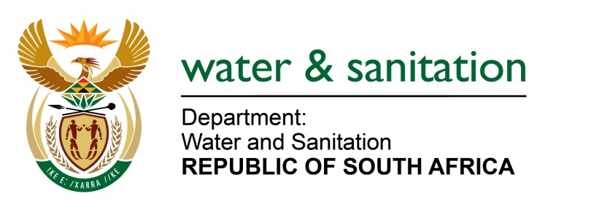

NATIONAL ASSEMBLY

FOR WRITTEN REPLY

QUESTION NO 2297

DATE OF PUBLICATION IN INTERNAL QUESTION PAPER: 12 JUNE 2015
(INTERNAL QUESTION PAPER NO. 21)

2297. Ms T E Baker (DA) to ask the Minister of Water and Sanitation:
(1) With regard to the amount of R352,4 million which was set aside to assist the nine municipalities affected by drought in KwaZulu-Natal, (a) which municipalities have received payments and (b) what amount has each municipality received to date;
(2) have funding agreements been signed with all affected municipalities; if not, (a) which municipalities have outstanding agreements and (b) what action has been taken to remedy this? NW2658E

---00O00---
REPLY:

(1)(a) Refer to table below regarding the nine municipalities affected by drought in KZN:

No. | Name of Municipality | Business Plan | Funding agreement | Amount received to date
1 | Umzinyathi District Municipality | Approved | Approved | R1 782 836.47
2 | Umkhanyakude District Municipality | Approved | Approved | R6 321 734.42
3 | Uthukela District Municipality | Received and pending approval | Received and pending approval | None
4 | Ugu District Municipality | Approved | Approved | None
6 | Zululand District Municipality | Approved | Approved | None
7 | UguDistrict Municipality | Approved | Approved | None
8 | IlembeDistrict Municipality | Approved | Approved | None
9 | Harry Gwala | Approved | Approved | None

---00O00---

