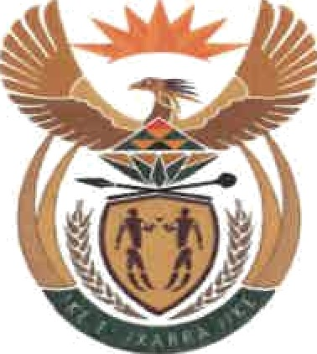

MINISTRY
INTERNATIONAL RELATIONS AND COOPERATION
REPUBLIC OF SOUTH AFRICA

NATIONAL ASSEMBLY QUESTION FOR WRITTEN REPLY
Date of Publication: 05 November 2021

2296. Mr R A Lees (DA) to ask the Minister of International Relations and

Cooperation:

With reference to her reply to question 31 for oral reply on 3 March 2021 and the reply by the President of the Republic, Mr M C Ramaphosa, to question 1077 on 24 May 2021 on alleged R118 million land purchase in the United States of America, what are the relevant details of the departmental officials who have been suspended in each case providing the
(a) full names, (b) positions in the department, (c) date(s) they were suspended and (d) date(s) that they returned to work? NW2614E

REPLY:

- Mr KE Mahoai and Mr C Ramashau

- Director-General and Chief Financial Officer (c) 10/02/2021 and 01/03/2021
(d) Both Officials were dismissed after due processes were followed. Mr Mahoai was dismissed on 04 September 2021. Mr Ramashau was dismissed on 01 October 2021.

1

