Ref:02/1/5/2

MINISTER

QUESTION NO. 2293 FOR WRITTEN REPLY: NATIONAL ASSEMBLY

A draft reply to Ms H O Hlophe (EFF) to the above-mentioned question is enclosed for your consideration.

MS NOSIPHO NGCABA
DIRECTOR-GENERAL

DATE:

DRAFT REPLY APPROVED/AMENDED

DR B E E MOLEWA, MP
MINISTER OF ENVIRONMENTAL AFFAIRS

DATE:
NATIONAL ASSEMBLY
(For written reply)

QUESTION NO. 2293 {NW2531E}
INTERNAL QUESTION PAPER NO. 26 of 2017

DATE OF PUBLICATION: 14 August 2017

Ms H O Hlophe (EFF) to ask the Minister of Environmental Affairs:
- What steps has her department taken to reduce greenhouse gas emissions; and
- with regard to the Greenhouse Gas Emission Reporting Regulations published under the National Environmental Management: Air Quality Act, Act 39 of 2004, (a) what steps have been taken to implement the regulations (b) will her department require companies operating more than one facility to submit separate greenhouse gas emission data for each of their facilities or will it accept one set of data for all the facilities?
2293. THE MINISTER OF ENVIRONMENTAL AFFAIRS REPLIES:

(1) Over the past six years, extensive work has been done to translate the National Climate Change Responses Policy (NCCRP) into practical action:

- Implementation of the National Mitigation System
Section 6 of the NCCRP lists the key elements in the overall approach to mitigation. The National Mitigation System, comprises the following elements and is directly implemented by the Department of Environmental Affairs:
- Introduction of desired emission reduction outcomes now called the sector emission targets (SETs);
- Allocation of carbon budgets at company level; and
- Establishment of a national emissions trajectory.

Phase 1 of the Mitigation System has already commenced, from 01 January 2016 and will extend to
31 December 2020. Phase 2 of the Mitigation System, will commence on 01 January 2021. Phase 1 will contains some of the elements of the full mitigation system, with further elements to be introduced in the second phase.

- Sectoral Emission Targets
The rationale for SETs is to set limits of greenhouse gas emissions (GHG) for sectors and subsectors as part of South Africa’s mitigation efforts, while achieving its developmental goals. SETs will be determined for three rolling 5-year periods, with national government departments (SET departments) being allocated responsibility to ensure emissions remain within the limits of the first 5-year period. The SETs are aligned with emissions categories in the national GHG inventory. The first Phase SETs have been set for the period 2016 to 2020. The second and subsequent phases SETs will be defined and allocated by 2018, pronouncing the 3 cycles for the period (2021-2025; 2026-2030 and 2031-2035); and will be reviewed every 5 years.

- Carbon Budgets
A carbon budget sets the maximum volume of emissions from certain activities that a company is allowed to emit over a certain time period. By assigning a carbon budget to a company, an indication is provided of the extent of greenhouse gas mitigation that is required within a specific time period. Furthermore, by providing companies with an understanding of how budgets are likely to be assigned in future phases, as well as how the budgets will be impacted by the shape of the trajectory, it sensitises them to how mitigation requirements may change in the future (even if the future quantum is not specified). Carbon budgets will be allocated for a period of five years, supported by the GHG Emissions Reporting regulations, which will facilitate the submission of GHG emissions data by companies.

- Mitigation Plans
The companies whom the I have given carbon budgets are expected to prepare, submit and implement mitigation plans to demonstrate how they are going to reduce/manage their GHGs towards achievement of their carbon budgets. For the first phase, companies will be empowered to prepare mitigation plans through the Pollution Prevention Plan regulations promulgated in July 2017. The plans will be reviewed every five years. Progress towards implementation of these plans is done every year and at the end of the five years (in line with the carbon budgets).

- The National Emissions Trajectory
The National GHG emissions trajectory serves as the country’s greenhouse gas emission reduction pathway over time. The first refinement of the National Trajectory emissions trajectory is planned for 2018, with an update every five years. The National Trajectory will inform what gets committed to the UNFCCC as Nationally Determined Contributions (NDCs).

- The Mitigation Potential Analysis
The Mitigation Potential Analysis (MPA) involves identifying and analysing mitigation options in key economic sectors. The MPA entails:
- Setting baselines and projecting greenhouse gas emissions in to the future;
- Conducting an in-depth assessment of the mitigation potential for key sectors and sub-sectors of the economy; and
- Identifying best available mitigation options for key sectors and sub-sectors which is formed by amongst other:
National GHG emissions are projected based on the National Greenhouse Gas Inventory, mentioned previously. Sector plans (policies and strategies) also form part of the inputs to the MPA. The Mitigation Potential Analysis will be periodically reviewed (every 5 years).

- Development and Implementation of Policies and Measures
The work here involves quantification or estimation (ex-ante) of effect of policies and measures (PAMs) on emission reduction based on currently implemented adopted and planned PAMs. To fill the gap to meet South Africa’s emission reduction objectives, new PAMs are recommended. The role of sectoral departments is very critical in the development of PAMs. The PAMs are very important in the process of achieving sectoral targets (SETs). The Carbon Tax is one of the policy instruments articulated through the NCCRP as one such policy intervention/ instrument to influence behavioural change on industry to internalize external costs associated with greenhouse gas emissions.

- National Greenhouse Gas Inventory Reporting System
As an international requirement, Decision 17/CP.8,3 of the UNFCCC states that non-Annexure I Parties (includes South Africa) shall, as appropriate and to the extent possible, provide in its national inventory, on gas-by-gas basis and its units mass, estimates of anthropogenic emissions of carbon dioxide (CO₂), methane (CH₄) and nitrous oxide (N₂O) by sources and removals by sinks – in line with the IPCC Guidelines.

Accurate GHG emissions inventories are essential for the following reasons:
- To fulfil the UNFCCC reporting requirements and also support the development of the national communications, Biennial Update Reports;
- Mitigation Potential Analysis;
- To evaluate mitigation options and to provide for GHG emissions reductions;
- To assess the effectiveness of policies and mitigation measures;
- To develop long term emissions projections;
- To monitor and evaluate the performance of South Africa’s GHG emissions profile; and
- Used as a basis for allocation of carbon budgets, DEROs/SETs, etc.

South Africa has already developed five national greenhouse gas inventories (1990, 1994, 2000, 2014, and 2017). These have been published nationally and included in various international reports to the UNFCCC. The 4th National Greenhouse Gas Inventory was published in December 2014, covering the 2000-2010 period. The Department of Environmental Affairs has recently finalised the 5th inventory, 2000-2012 National GHG inventory. South Africa’s greenhouse gas (GHG) Inventory will now be compiled and published on a biennial basis.

- Implementation of the National Greenhouse Gas Inventory Reporting Regulations
The Minister has promulgated the National GHG Reporting Regulations to encourage the reporting of national GHG emissions annually. The main objective of these regulations is to introduce a single national reporting framework for the reporting and dissemination of information related to GHG emissions. Reporting of this GHG data will be done through the National Atmospheric Emissions Inventory System (NAEIS).

- Implementation of the Climate Change Near-term Priority Flagship Programmes
The Climate Change Flagship Programmes are strategic measures implemented by the South African Government intended to serve as a rallying point to trigger a large-scale transition to a lower carbon economy and a more climate resilient South Africa. They are government led programmes and they provide the certainty needed to stimulate the investment required for these transitions. The Programmes place government at the forefront of increasing the use, visibility and recognition of climate change response technologies and services, facilitating their rapid diffusion. South Africa’s implementation capability has grown tremendously, characterised by more effective systems and processes, and a more capable workforce that is better able to achieve strong, well-coordinated progress in responding to climate change. The Department of Environmental Affairs, other national government departments and key implementation partners intensified their efforts towards the development, implementation and scaling-up of climate action in their respective sectors. In partnership with the relevant lead departments and implementers, the Department of Environmental Affairs is currently working on the development and implementation of the two new Flagship Programmes and the expansion of several existing flagship programmes.

The second phase of the Climate Change Flagship Programmes, which began in 2012, has focused on (i) deepening the impact of existing programmes; (ii) expanding the initial set of Flagship Programme activities to incorporate increasingly ambitious and innovative elements; and (iii) introducing new Flagship Programmes to anchor climate action leadership and reflect the importance of both adaptation and mitigation action as part of a holistic national climate change response.

Figure 1 shows the updated list of South Africa’s Climate Change Flagship Programmes and investment priority areas. The shaded boxes indicate new Climate Change Flagship Programmes included in the 2016 priority work packages.

CORRESPONDING CLIMATE CHANGE FLAGSHIP PROGRAMME
CLIMATE CHANGE PRIORITY INVESTMENT AREAS

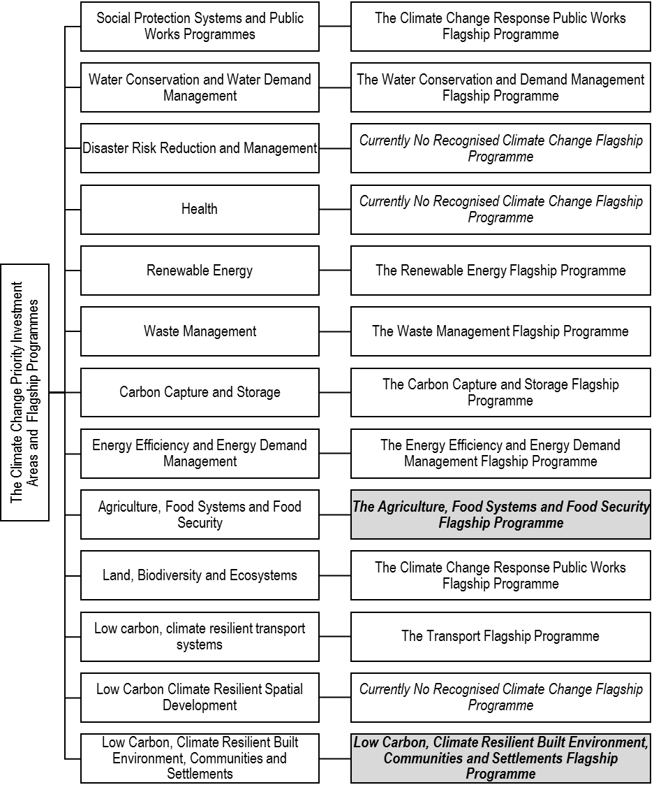
Figure 1: South Africa’s Climate Change Priority Investment Areas and Corresponding Expanded Climate Change Flagship Programmes (2016)
The 2016 priority work packages included pre-existing Climate Change Flagship Programmes (first described in 2011), as well as new Flagship Programmes established since the publication of the NCCRP.

Table 1 provides a summarised description of the current Climate Change Flagship Programmes focus areas. Table 1 Current focus areas of the Climate Change Flagship Programmes

Climate Change Flagship Programmes 2016 Priority Work Package |  | Climate Change Flagship Programmes | Envisaged Climate Change Outcome
Work Package | Core Focus
Energy Efficiency in Public Buildings Programme | - Market development and expansion  - Leveraging private sector investment | Energy Efficiency and Energy Demand Management Flagship Programme | Urgent, comprehensive and coordinated large-scale implementation of energy efficiency measures and technologies, across all sectors of South Africa’s economy and society anchoring and stimulating the establishment of inclusive and localised energy services and technologies.
Diversion of Municipal Solid Waste from Landfill | - Demonstration scale implementation and development of implementation blueprints  - Strengthening the regulatory framework | Waste Management Flagship Programme | Accelerated investment in, and implementation of large scale waste minimisation; recycling and composting of organic waste; using waste-to-energy opportunities available within the solid-, semi-solid- and liquid-waste management sectors; and establishing appropriate infrastructure and value chains to enable widespread uptake of low carbon waste management approaches.
Wastewater Biogas Generation for Electricity
Tsamaya Sustainable Urban Transport NAMA | - Strengthening the regulatory framework  - Dedicated implementation support | Transport Flagship Programme | Accessible and integrated transport systems that prioritise the use of more efficient spatial design, transport networks and operations; low emissions transport modes, vehicles, fuels, technology; non-motorised transport; and climate-resilient infrastructure to enhance social mobility; access to economic opportunities and levels of rural access and connectedness
Rainwater Harvesting Strategy Development | - Strengthening of the regulatory framework  - Development and piloting of implementation blueprints | Water Conservation and Demand Management Flagship Programme | Urgent and large-scale implementation of efficient water systems, water storage and infrastructure coupled with prudent resource and demand management, and informed behavioural change
Small-scale Embedded Energy Generation | - Strengthening the regulatory framework  - Supporting systematic implementation | Renewable Energy Flagship Programme | Widespread development, integration and use of, and affordable access to, South Africa’s abundant renewable energy (RE) resources through the large-scale deployment of appropriate technologies at all scales driving innovation; localisation of RE goods, services and technologies; energy security and economic growth.
Hydrogen and Fuel Cell Technologies | - Market development  - Demonstration scale implementation and development of implementation blueprints
Agriculture, Food Systems and Food Security Flagship Programme | - Strengthening the regulatory framework  - Demonstration scale implementation of integrated approaches and new systems | Agriculture, Food Systems and Food Security Flagship Programme | Widespread and urgent establishment of climate-smart agriculture, agro-processing and food production systems to enhance productivity and climate resilience, at all scales of production; and successfully integrating agro-ecological practices and resource efficient approaches to drive the growth and competitiveness of South Africa’s agricultural sector.
Low Carbon, Climate Resilient Built Environment, Communities and Human Settlements | - Strengthening the regulatory framework  - Demonstration scale implementation of integrated approaches and new systems | Low Carbon, Climate Resilient Built Environment, Communities and Human Settlements Flagship Programme | Resilient, low emissions and spatially efficient, rural, urban and coastal communities, settlements and infrastructure incorporating a high-performance green built environment, green building practices, green retrofits of existing buildings, protecting and enhancing natural ecosystems and extensive green infrastructure networks.
Land, Biodiversity and Ecosystems | - Strengthening the regulatory framework  - Demonstration scale implementation of integrated approaches to rehabilitation and management of grasslands, sub-tropical thicket, forests and woodlands | The Climate Change Response Public Works Flagship Programme | Large-scale investment in, and expansion of, the restoration and rehabilitation of South Africa’s natural resource base; including management of invasive species; enhancing ecosystem integrity and resilience; creating and enhancing carbon sinks; ecosystem-based adaptation approaches and better management of marine resources, fisheries and ecosystems:

- South Africa’s Green Climate Fund Strategic Investment Framework
The Climate Change Flagship Programmes are South Africa’s main link to the primary climate finance mechanism of the United Nations Framework Convention on Climate Change (UNFCCC), the Green Climate Fund (GCF) and other funding opportunities. Just as the ability to achieve South Africa’s NDC is premised on accessing adequate finance, technology and capacity building support; the required support needs to be directed by a clearly articulated set of investment priorities. In addition, this needs to be led by an identifiable champion, governance structure and implementation approach. The Climate Change Flagship Programmes fulfil this specific function. The Climate Change Flagship Programmes provide a focal point for attracting and leveraging investment from both the private and public sectors at the scale required to enable meaningful climate action.

The GCF presents South Africa with a potential opportunity to access a significant part of the financial support required to drive the national climate change response. To fully utilise the opportunity presented by the GCF, a national GCF Strategic Framework has been developed to enable a coherent engagement with the GCF and to ensure that South Africa’s GCF investments are aligned to the national climate change response priorities.

2 (a) The department has effectively administered an offline reporting system as required by the Greenhouse Gas Emission Reporting Regulations, in the absence of an online reporting platform. Thus far, between the period May 2017 and present, the department has received registrations from 140 data providers nationally that have registered a total of 595 facilities that meet the reporting thresholds specified in the regulations. Currently the department is undertaking verification work in order to conclude the first phase of the registration process and is also intending to further extend the registration period through a consultative process, as called for by various affected stakeholders and data providers.

In addition the Department has also published detailed Technical Guidelines for Measurement Reporting and Verification of Greenhouse Gas emissions by Industry, which provide and enable data providers affected by the reporting regime to understand the reporting requirements and assist them in developing emission reports that are in line with the reporting requirements. In addition to the technical guidance, the department is also putting in place Greenhouse Gas Reporting Guidelines and Reporting Tools that will provide clarity on procedural aspects of the reporting programme and further enhance the successful implementation of the Greenhouse Gas Emission Reporting Regulations.

Furthermore, the Department is also working with the National Treasury, through the Partnership for Market Readiness programme, a programme funded by the World Bank, to modify the National Atmospheric Emissions Inventory System (NAEIS) which is the primary reporting system for the reporting of Greenhouse Gases, in order to meet the reporting requirements in line with the Greenhouse Gas Emission Reporting Regulations. This work will enable future reporting to be done using electronic (Web-based) reporting via the NAEIS system and this work is currently at procurement stage.

The department also has been and continues to participate in various public and private sector-led capacity building initiatives aiming to create common understanding of the reporting regime and to play an active role in creating consensus about the reporting requirements amongst key stakeholders and affected data providers.

Whilst building capacity to understand the reporting regime amongst external stakeholders, as captured above, the department is also building its technical and institutional capacity in order to effectively administer the mandatory GHG reporting programme by putting systems in place to improve business intelligence of the department and putting in place sound quality control and assurance procedures in order to ensure that such reporting is done sustainably in the future.

Whilst aiming to finalise the registration process in the second quarter of the 2017/18 financial year, the department is also preparing itself to receive the first round of emissions reports from data providers in March 2018 and is providing the necessary technical assistance to various data providers on technical and other methodological aspects of the Greenhouse Gas Emission Reporting Regulations

2 (b) In the current design of the reporting programme, data providers (companies) are required to submit one emissions report for all its facilities and are not required to submit separate emissions reports for each of its facilities. It is the view of the department that, in future, reporting of Greenhouse gases should follow international best practice and move towards facility-level reporting and the department is planning on introducing such level of reporting through a phased approach in the near future. However, the current level of reporting is sufficient to meet our international reporting obligations under the UNFCCC and to provide a robust scientific evidence base that helps us track progress towards implementation of Nationally Determined Contributions (NDCs) and other key National Climate Change mitigation policy programmes and commitments.

---ooOoo---

