36/1/4/1(201800227)
NATIONAL ASSEMBLY

FOR WRITTEN REPLY

QUESTION 2292
DATE OF PUBLICATION IN INTERNAL QUESTION PAPER: 17 AUGUST 2018 (INTERNAL QUESTION PAPER NO 23-2018)

2292. Mr M Waters (DA) to ask the Minister of Police:

(a) What is the current (i) actual and (ii) optimal number of police officers involved with sector policing at the Boksburg North Police Station and (b) by what date will the specified police station receive its full complement of sector police officers?
NW2469E
REPLY:

(a)(i)(ii) and (b)

(a)  Current | (i)  Actual | (ii)  Optimal | (b)  Date
42 | 62 | 74 | In January 2019, 14 new recruits will  be received.

Reply to question 2292 recommended/not recommended

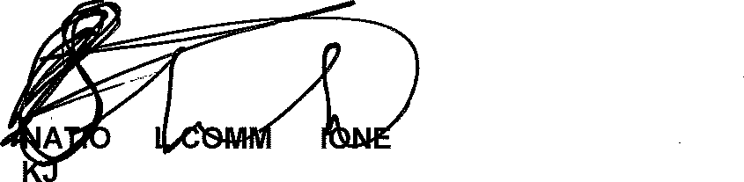
GENERAL NA ISS R: SOUTH AFRICAN POLICE SERVICE
SITOLE (SOEG)

Date:
26\8 -t8- 2 3

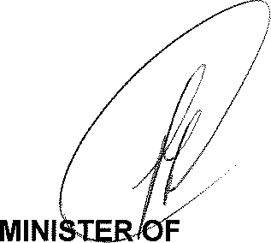
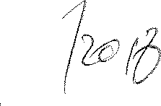
Reply to question 2292 approved/n
POLICE
BH CELE, MP

