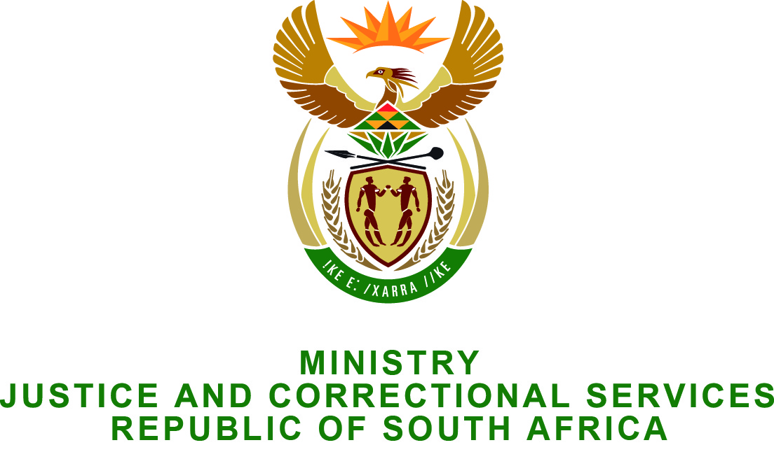

NATIONAL ASSEMBLY
QUESTION FOR WRITTEN REPLY
PARLIAMENTARY QUESTION NO.: 2290
DATE OF QUESTION: 12 JUNE 2015
DATE OF REPLY: 26 JUNE 2015

Mr Z N Mbhele (DA) to ask the Minister of Justice and Correctional Services:
(1) (a) How many family advocate offices are there, (b) at which courts are the specified offices situated and (c) how many social workers dealing with custody matters are at each of the specified offices;
(2) (a) which welfare organisations does his department rely upon to deal with custody matters and (b) what financial subsidy does his department give each welfare organisation? NW2651E
REPLY:
- The Minister of Justice and Correctional Services wishes the Honourable member to know that there are a total of 25 Family Advocate Offices countrywide. A full description of the services are as follows:
- Name of Office | - Location | - Number of Social Workers dealing with custody matters
Family Advocate Pretoria | 4th Floor, Die Meent Building, c/o Thabo Sehume & Pretorius Streets | 12
Family Advocate Johannesburg | 94 Pritchard Street, 13th Floor, Schreiner Chambers, Johannesburg | 10
Family Advocate Palm Ridge | Palm Ridge Magistrate’s Court | 1
Family Advocate Vossman | Vossman Magistrate’s Court | 2
Family Advocate Nelspruit | No 3 Marloth Street, Nelspruit | 7
Family Advocate Polokwane | Wyndom park Building, 23 Rabie Street, Polokwane | 7
Family Advocate Sibasa | Thohoyandou Magistrate’s Court | 2
Family Advocate Mafikeng | 461/805 Steve Biko Drive, Unit 2, Mmabatho | 4
Family Advocate Rustenburg | Rustenburg Magistrate’s Court | 1
Family Advocate Kimberley | 5th Floor, New Public Building (Magistrate Court), c/o Knight & Stead Street, Kimberley | 7
Family Advocate Upington | Upington Magistrate’s Court | 2
Family Advocate Durban | 15th Floor Maritime House, 143 Grove Street Durban | 10
Family Advocate Pietermaritzburg | Pietermaritzburg Magistrate’s Court | 6
Family Advocate New Castle | New Castle Magistrate’s Court | 3
Family Advocate Ntuzuma | Ntuzuma Magistrate’s Court | 1
Family Advocate Cape Town | 55 Union Castle Building, 10th Floor ,c/o House Street & St George’s Mall, Cape Town | 10
Family Advocate George | Batleur Park Building, Cnr Cathedral & Cradock Street, George | 3
Family Advocate Worcester | 67 High Street, Worcester | 2
Family Advocate Mitchells Plein | Mitchells Plein Magistrate’s Court | 1
Family Advocate Port Elizabeth | No. 1 Bird Street, Central, Port Elizabeth | 10
Family Advocate East London | 29 St Peters Road , Southernwood, East London | 4
Family Advocate Graaff Reinett | Graaff Reinett Magistrate’s Court | 3
Family Advocate Mthatha | 29 St Peters Road , Southernwood, East London | 2
Family Advocate Bloemfontein | 163 A Nelson Mandela Drive, 2nd Floor Sanlam Building, Bloemfontein | 8
Family Advocate Welkom | Welkom Magistrate’s Court | 2
- (a) The office of the Family Advocate does not rely on external Welfare Organisations for Custody matters but obtains collateral reports from the following organisations when necessary:
PROVINCE | ORGANISATIONS
LIMPOPO | - Child Welfare  - Suid Afrikaanse Vroue Federasie  - Huis Maroela  - Families South Africa (FAMSA)
GAUTENG | - Department of Social Development
MPUMALANGA | - N. A.
NORTH WEST | - Mental Health  - Suid Afrikaanse Vroue Federasie  - Child Welfare SA
EASTERN CAPE | - Families South Africa (FAMSA)  - Afrikaanse Christelike Vrouevereniging( ACVV)  - Christelike Maatskaplike Raad (CMR)  - Department of Social Development
FREE STATE | - Afrikaanse Christelike Vrouevereniging( ACVV)  - Christelike Maatskaplike Raad (CMR)  - Department of Social Development
WESTERN CAPE | - Child Welfare  - Badisa  - Afrikaanse Christelike Vrouevereniging (ACVV)  - CMC  - Ukakhanya  - Parent Centre  - Child Line  - Mosaic  - Litha labantu  - Valley development projects
NORTHERN CAPE | - Families South Africa (FAMSA)  - Department of Social Development  - Child Welfare  - NG Welsyn  - Afrikaanse Christelike Vrouevereniging (ACVV)  - South African National Council on Alcoholism & Drug Dependence (SANCA)

- (b) No subsidies are paid out to welfare organisations by the Department of Justice and Constitutional Development.

