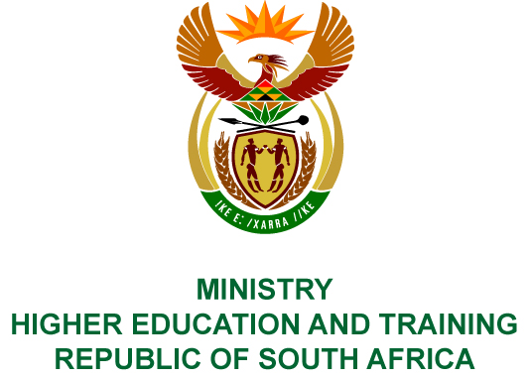
Private Bag X893, Pretoria, 0001, Tel (012) 312 5555, Fax (012) 323 5618
Private Bag X9192, Cape Town, 8000, Tel (021) 469 5150, Fax: (021) 465 7956
Memorandum from the Parliamentary Office
NATIONAL ASSEMBLY
FOR WRITTEN REPLY
QUESTION 229
DATE OF PUBLICATION OF INTERNAL QUESTION PAPER: 16/02/2018

(INTERNAL QUESTION PAPER NO 2 OF 2018)
Ms N P Sonti (EFF) to ask the Minister of Higher Education and Training:
Whether the National Institute for the Humanities and Social Sciences paid any bonuses in the (a) 2014-15, (b) 2015-16 and (c) 2016-17 financial years; if so, (i) what was the amount paid to each person in each specified financial year, (ii) for what reason was each bonus paid in each case and (iii) did the payment of each bonus comply with the cost-cutting measures and regulations of (aa) the National Treasury, (bb) her department and (cc) the Auditor-General of South Africa?
NW250E

REPLY:
The National Institute for Humanities and Social Sciences (NIHSS) has provided the following responses to the questions posed.
- No, the NIHSS did not pay bonuses for the 2014-15 financial year
- No, the NIHSS did not pay bonuses for the 2015-16 financial year
(c) (i) For the year 2016/17, a total amount of R624 865, 87 was paid in bonuses to 25 persons employed or appointed at the National Institute for the Humanities and Social Sciences. The breakdown is as follows:
94 000.63
48 212.04
38 367.41
46 040.89
84 119.91
16 737.33
11 414.74
14 268.42
29 597.65
7 555.65
15 531.56
12 942.97
6 194.99
6 253.42
3 495.17
12 035.64
47 247.00
24 589.91
22 054.45
47 242.00
24 589.91
22 054.45
18 221.61
4 326.27
10 096.50
39 375.00
3 020.06
9 166.67
Total: 624 865.87
- The bonuses paid were performance based for the 2016/17 financial year. The rate (percentage) was based on the performance rating of staff members in terms of the year-end performance evaluations. The following methodology applied:
- Bonuses were apportioned for the number of months worked in the financial year by staff members
- Bonuses exclude maternity and paternity leave
- Bonuses were paid only if a rating of 3.5 and above was achieved by staff members
- Bonuses excluded fixed term employees who worked less than 6 months in the financial year
- Bonuses excluded permanent employees who worked less than 2 months
(aa) The expenditure complied with the NIHSS’s policies. The NIHSS is neither a Department, nor a constitutional institution, nor a public entity listed in Schedule 2 or 3, and therefore the Public Finance Management Act is not applicable to the NIHSS.
(bb) Spending is managed by the NIHSS in terms of its policies.
(cc) The Auditor-General of South Africa audits the NIHSS in terms of Section 38 of the Higher Education Act and since its inception has received unqualified audit opinions.

