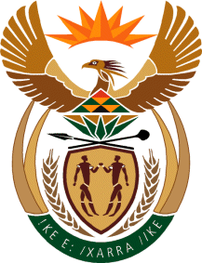

MINISTRY: COMMUNICATIONS
REPUBLIC OF SOUTH AFRICA
Private Bag X 745, Pretoria, 0001, Tel: +27 12 473 0164 Fax: +27 12 473 0585
Tshedimosetso House,1035 Francis Baard Street, Tshedimosetso House, Pretoria, 1000

NATIONAL ASSEMBLY
QUESTION FOR WRITTEN REPLY
QUESTION NUMBER: 229
DATE OF PUBLICATION: FEBRUARY 2016
Mr M Q Ndlozi (EFF) to ask the Minister of Communications:
Has her department awarded any contracts to companies indirectly or directly owned by certain persons (names furnished) in the (a) 2012-13, (b) 2013-14 and (c) 2014-15 financial years; if so, in each specified financial year, (i) how many times were such contracts awarded and (ii) for what amount? NW231E

REPLY: MINISTER OF COMMUNICATIONS
The Department has not awarded any contract to companies directly or indirectly owned by the said persons.

MR NN MUNZHELELE
DIRECTOR GENERAL [ACTING]
DEPARTMENT OF COMMUNICATIONS
DATE:

MS AF MUTHAMBI (MP)
MINISTER OF COMMUNICATIONS
DATE

