NATlDi\IAL A9REMCLY

FOR SRI ENI3EPLY
OU.ESTIQN 2z89

Q/tYE OF PUBLICATION !)'t INTERNAL QUESTIOI4 PAPER: 17 AU$UST1018
flNTGRNAL QUESTION PAPMR NO 23-2018)
22ae. Mr Z N Mbheta (DA) to aak the Minister of Pollca:

With reference to the Reply ID question 220Y on 31 Qctobar 2016, what Is the total number of (a) flying aquads that were In operation In each province and (b) SA Police Service oPlcera who wets aaelgnad to each spaotfled flytng squad (I) tn the (aa) 1016-17 end (bb) 2017-t8 tlnarlclal years and (li) alnce Aprll ao1st
NW2485E

m•mb•tsat squxds embezxat o t ona) ba
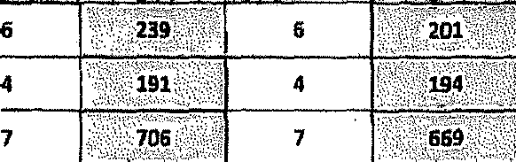
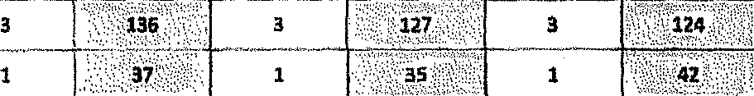
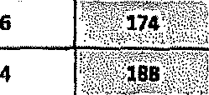

...,................. ..t‹xJoR exaut
HJuxH0ThE£l LIEUTGNANT OENEfiAL
N DIVISIONAL CQMMIB8IONER: VISIBLE POMCINQ
' 9J JEPHTA
Dale: jgjg tt- 11

FOR WRFTTEtJ REPLY: OUE9TION 2S80: DATE OP PUBLICATION IN !KTERNAL QUESTION PAPER: t7 AUQU9T g018. (INTERNAL QUB8TION PAPER NO 29-Z018)
Raply to question 2Z89. teaommended

MEUTENANT GENERAL TIONAL COMt4lbSlONER: POLICING

Reply to quaatlon 2289 recommended

QEtJERAt.
AFRICAN POLICE 8ERVICB

Raply to question 226 approved/notappfeygd
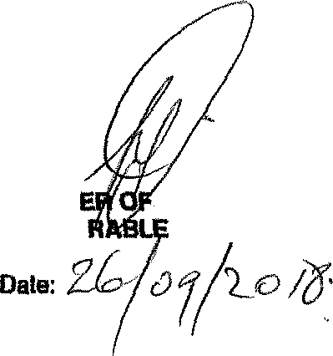
MlklCT HONOU
POLICE
BH C,ELE, MP

