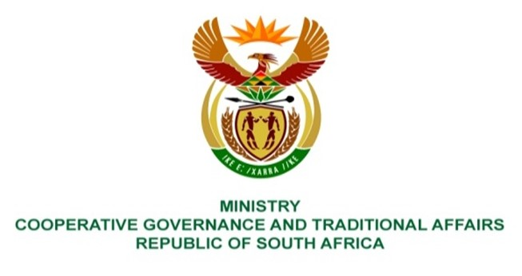

NATIONAL ASSEMBLY
QUESTIONS FOR WRITTEN REPLY

QUESTION NUMBER 2284
DATE OF PUBLICATION: 17 JUNE 2022

QUESTION:
2284. Ms A M M Weber (DA) to ask the Minister of Cooperative Governance and Traditional Affairs:
(1) What steps will she and/or her department take to assist the community of Doornkop in Gauteng that needs help with water supply as the local municipality does not have sufficient water supply and service delivery is lacking (details furnished);
(2) What intervention measures will she put in place in order to provide water to the entire area as the current bore holes cannot meet the demand and the occupants of the informal part of Doornkop are connecting pipes to the main water supply line and they use all the water before it reaches the community;
(3) Whether she has been informed that on 19 September 2020 a notice was going to be delivered to the occupiers of Doornkop who illegally connected to the borehole; if not, what is the position in this regard; if so, (a) on what date was the notice served, (b) will she furnish Ms A M M Weber with a copy of the notice and (c) how will she ensure that the notice will be enforced? NW2701E

REPLY:

This question should be directed to the Department of Water and Sanitation (DWS) because in terms of the National Water Act, 1998 (Act No. 36 of 1998), the DWS is responsible for the regulation of water use in South Africa by ensuring that water is allocated equitably and used beneficially in the public interest. Furthermore, the DWS is mandated to protect, manage and control the groundwater resources of the country.

It is hereby recommended that this PQ 2284 be re-directed to the Department of Water and Sanitation in accordance with their mandate provided by the relevant legislation.

